R. C. Patel Educational Trust’s

**Institute of Management Research and Development, Shirpur**

**Library Activities: 2023-24**

**Event Name :- “Library Orientation 2023-24”**

**Event Type :-**  Library Orientation Program for 1st  year students of UG and PG.

**Presented by:- Kavita G. Patil, Nilima D. Patil, Dr. Laxmikant Sharma.**

**Event Date :-** 25th and 26th July,2023 for UG and 23rd August, 2023 for PG

**Event Time:-**

|  |  |  |
| --- | --- | --- |
| **Course** | **Date** | **Time** |
| IMCA | 25/07/2023 | 09.00am to 10.00am |
| BBA-I-Div-A & B  BMS-I | 26/07/2023 | 09.00am to 10.00am |
| BCA-I-Div-A, B & C | 26/07/2023 | 12.00pm to 01.00pm |
| MCA-I | 23/08/2023 | 12.30pm to 01.30pm |

**Benefited:- 450+** Students of UG & PG

**Event Details: “Library Orientation Program” was organized in IMRD for the first year students of UG & PG during induction program.** In this program, all the newly enrolled students were given information regarding Circulation Service, library time table, awareness regarding OPAC, awareness regarding e-resources available in the library through PPT presentation. **The objective of this program was to make aware new students with library collection, functioning of library and also rules, regulations of the library.** It helped students to know how to make use of library resources effectively and efficiently. Librarian Mrs. Kavita G. Patil, Assistant Librarian Mrs. Nilima D. Patil, library committee members took efforts to make this activity successful.

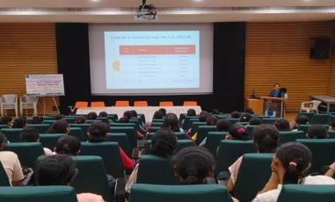 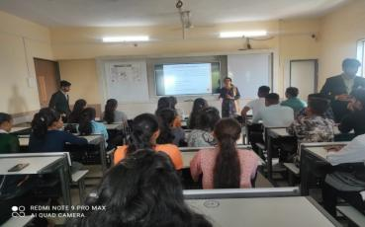

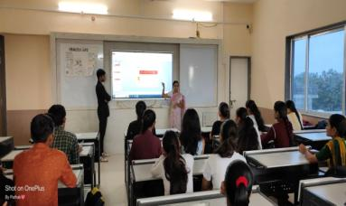

R. C. Patel Educational Trust’s

**Institute of Management Research and Development, Shirpur**

**Library Activities: 2023-24**

**Event Name :-** “Book Exhibition 2023-24”

**Event Type :-** Celebration of Librarians Day with Dr. S. R. Ranganathan Idol Worship

Book Exhibition for 1st year UG and IMCA students.

**Event Date :-** 12th August, 2023

|  |  |  |
| --- | --- | --- |
| **Course** | **Date** | **Time** |
| IMCA-I | 12/08/2023 | 10.00am. to 10.30am. |
| BBA-I-A | 12/08/2023 | 10.30am. to 11.00am. |
| BBA-I-B | 12/08/2023 | 11.00am to 11.30am. |
| BMS-I | 12/08/2023 | 11.30pm. to 12.00pm. |
| BCA-I-A | 12/08/2023 | 01.30pm. to 02.00pm |
| BCA-I-B | 12/08/2023 | 02.00pm to 02.30pm. |
| BCA-I-C | 12/08/2023 | 02.30pm. to 03.00pm |

**Event Time:-**

**Benefited:- 307** Students of UG and PG

**Event Details:** Librarians day was celebrated with Dr. S.R. Ranganathan Idol Worship and Book Exhibition was organized in IMRD for the first year students of UG & IMCA on the occasion of Birth Anniversary of Dr. S. R. Ranganathan. Syllabus oriented books and Motivational, aptitude, reasoning, group discussion and interview related books were shown in the exhibition. Latest periodicals and magazines were also shown in this exhibition. **The objective of this program was to make aware new students with multiple book’s titles and authors of different subject of the particular course.** It helped students to make use of library resources effectively. Librarian Mrs. Kavita G. Patil, Assistant Librarian Mrs. Nilima D. Patil, library committee members took efforts to make this activity successful.

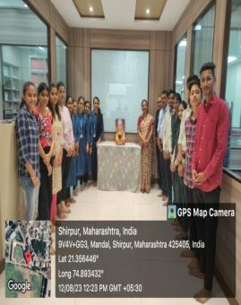 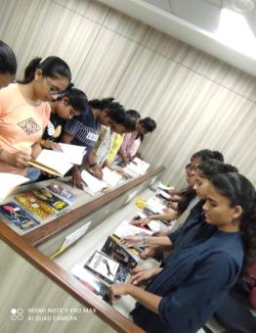 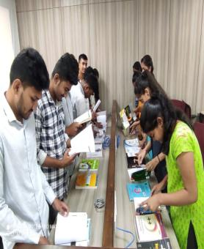

R. C. Patel Educational Trust’s

**Institute of Management Research and Development, Shirpur**

**Library Activities: 2023-24**

**Event Name : - “Reading Inspiration Day Celebration ”**

**Event Type : - “APJ Abdul Kalam Idol Worship”**

**Event Date : -** 16th Oct, 2023

**Event Details:-** In order to encourage the reading habit and in keeping with the spirit of learning and creativity for success, Dr. APJ Abdul Kalam's birth anniversary was celebrated as **Reading Inspiration Day.** On this occasion, Director of the Institute Dr. Vaishali Patil garlanded the image of Dr. APJ Abdul Kalam. Books of Dr. APJ Abdul Kalam were displayed to inspire students for reading. Positive attitude, determination and motivational thoughts of Dr. APJ Abdul Kalam help students stay inspired and motivated to reach their goals. To realize the importance of reading, students were guided to use library resources fully. On this occasion, Assistant Director Mr. Manoj N. Behere, IQAC Coordinator Dr. Dr. Manoj Patel, Head of UG Department Dr. Tushar Patel and other faculty members were present on the platform. Librarian Mrs. Kavita G. Patil, Assistant Librarian Mrs. Nilima Patil and Library Committee members took the efforts to make this event successful.

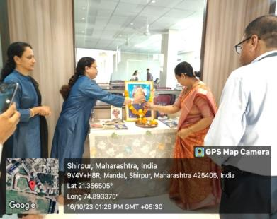 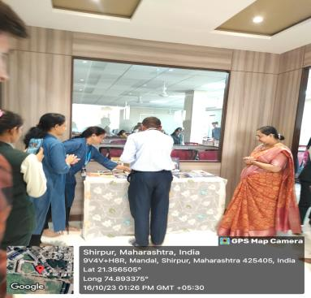

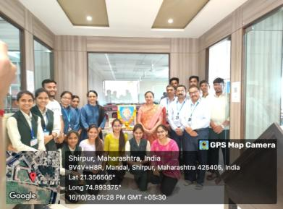 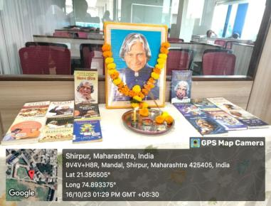

R. C. Patel Educational Trust’s

**Institute of Management Research and Development, Shirpur**

**Library Activities: 2023-24**

**Event Name : - National Library Week - “Open a Book, Open Your Mind”**

**Event Type : - “Book Reading Campaign”**

**Event Date : -** **14th November to 20th November, 2023.**

**Benefited :- Total 144 students visited to library for Book Reading Campaign.**

**Event Details:-** During National Library Week, Book Reading Campaign was organized by Institute Library. **National library Week was celebrated from 14th November to 20th November, 2023. Total 144 students visited to the library and read books according to their interest. The faculty members also visited to the library.** For the success of this Book Reading campaign, the backbone of the ecosystem Dr. Vaishali Patil was guided, Assistant director Manoj Behere sir and IQAC Coordinator Dr. Manoj Patel, Head of UG Department Dr. Tushar Patel sir also visited library for this Book Reading Campaign. With the objective of motivating students for developing reading habit and make aware of the importance of reading, “Book Reading Campaign” helped all students to keep their ignorance away in terms of knowledge, learning and information. Library committee members Dr. L. M. Sharma, Mr. Sachin Surana, Mrs. Chhaya Patil and Librarian Kavita Patil, Assistant Librarian Mrs. Nilima Patil took the efforts to make the event successful.

R. C. Patel Educational Trust’s

**Institute of Management Research and Development, Shirpur**

**Library Activities: 2023-24**

**Event Name** : - International Women’s Day, 2024

**Event Type** : - Essay Competition

**Event Date** : - 7th March, 2024

**Event Time** : - 11.00am to 11.45am

**Benefited** : - 66 Students

**Objective** : - 1. To encourage and raise the awareness of women's rights.

2. To achieve equal opportunity status in all walks of life.

**Event Details:**- **Essay competition** was organized for the students by **library department of the institute on 8th March, 2041**. Honourable guest Mr. Mahendra Mali, Tehsildar of Shirpur and Honourable Mrs. Neeta Sonawane, SVEEP, Nodal Officer and Respected Dr. Vaishali B. Patil ma’am visited to the institutional library to inaugurate the competition. Out of 66 participated students in Essay Competition, Three winners of the competition were awarded with prizes. In this Essay Competition, 3 Topics were given to the students such as: 1. Empowering Women: A Need of 21st Century 2. Importance of Women’s Health: A Necessity or Human Right 3. Challenges for Women in Rural Area. Among responded students, top 3 winners were selected as per highest marks criteria.

|  |  |  |
| --- | --- | --- |
| **Rank** | **Winners** | **Class** |
| **1st** | **Firake Jayashri Ravindra** | **MCA-I** |
| **2nd** | **Chaudhari Divya Santosh** | **BBA-II-A** |
| **3rd** | **Agrawal Rashi Amrish** | **BBA-I-A** |

Dr. Laxmikant M. Sharma and Mrs. Chhaya S. Patil has taken efforts for essay evaluation. Librarian Mrs. Kavita G. Patil, Assistant Librarian Mrs. Nilima D. Patil and library committee members took efforts to make this activity successful.

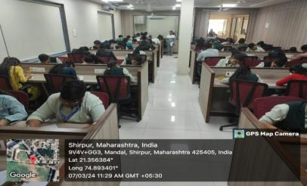 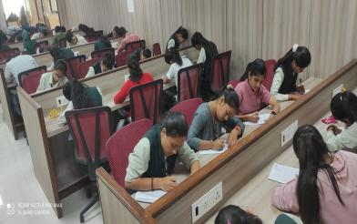

R. C. Patel Educational Trust’s

**Institute of Management Research and Development, Shirpur**

**________________________________________________________**

**Best User Award for A.Y. 2023-24**

|  |  |  |
| --- | --- | --- |
| **Sr. No.** | **Best User Award Winners** | **Class** |
| 1 | Jadhav Gayatri Ramesh | BCA - 2nd Yr. |
| 2 | Wagh Monali Bharat | BBA - 2nd Yr. |
| 3 | Rajput Ashwini Mahendrasing | BMS - 2nd Yr. |
| 4 | Girnare Sumit Manoj | I-MCA - 3rd Yr. |
| 5 | Mahajan Pranjal Jitendra | MCA – 1st Yr. |

Best User Award is given on the basis of student’s visits to the library, circulation of books, behaviour of student, result performance etc. The best user award is given a student from each course annually to accelerate the use of the rich resources of the institute library. It results in motivating students for developing reading habit and utilizing library resources effectively.

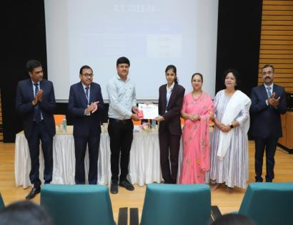 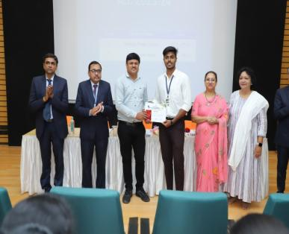

R. C. Patel Educational Trust’s

**Institute of Management Research and Development, Shirpur**

**Library Activities: 2023-24**

**KBP Earn and Learn Scheme for A.Y. 2023-24**

|  |  |  |  |
| --- | --- | --- | --- |
| **Sr. No.** | **Name of the Student** | **Class** | **Category** |
| 1 | Badgujar Divya Sanjay | IMCA-II | OBC |
| 2 | Bhonde Ganesh Sanjay | IMCA-III | OPEN |
| 3 | Borse Sandip Gokul | BCA-II-A | OBC |
| 4 | Choudhari Swastik Sunil | IMCA-III | OBC |
| 5 | Girase Neha Gotusing | MCA-I | OPEN |
| 6 | Girase Prajakta Hitendra | MCA-I | OPEN |
| 7 | Girase Priti Bhojusing | MCA-I | OPEN |
| 8 | Joshi Diksha Shishir | BBA-II-A | OPEN |
| 9 | Kapate Vivek Madhukar | BCA-I-A | OBC |
| 10 | Kavishwar Rajashri Girish | BMS-I | NT-B |
| 11 | Khairnar Nikhil Nandu | BBA-I-A | OBC |
| 12 | Koli Savita Sitaram | BBA-II-A | ST |
| 13 | Mahale Om Khushalchandra | BCA-II-C | OBC |
| 14 | Mali Nandini Mukesh | IMCA-IV | OBC |
| 15 | Mali Parth Manoj | BCA-I-B | OBC |
| 16 | Mali Tejaswini Ravindra | MCA-I | OBC |
| 17 | Pardeshi Ashwini Yogendra | BMS-II | OBC |
| 18 | Patil Hitesh Jagdish | IMCA-I | OBC |
| 19 | Patil Kuldip Bhagwan | IMCA-III | OBC |
| 20 | Patil Mahesh Ravsaheb | BCA-I-B | OBC |
| 21 | Patil Pravin Tukaram | BCA-I-B | OBC |
| 22 | Patil Sapana Arun | BMS-II | OBC |
| 23 | Patil Sarvesh Yogesh | IMCA-III | OBC |
| 24 | Patil Shreyas Sunil | IMCA-II | OBC |
| 25 | Patil Vinay Bhikan | MCA-I | OBC |
| 26 | Pawar Chetan Rajendra | BCA-I-C | OBC |
| 27 | Rajput Ashwini Mahendrasing | BMS-II | OPEN |
| 28 | Rajput Gangotri Sandip | BCA-I-C | OPEN |
| 29 | Saner Om Jitendra | IMCA-II | OBC |
| 30 | Sonar Lina Ghanshyam | BCA-II-A | OBC |
| 31 | Suryavanshi Sahil Umesh | BBA-II-B | NT-B |
| 32 | Tiwari Mehul Sanjay | IMCA-I | OPEN |

**Total 32 students** were benefited under this Earn and Learn scheme in **A.Y.2023-24**. Students worked in various departments of the institute such as office, T&P Cell, Library, Computer Lab and Sports. As per University Fund of Rs. 30 Per student, total **Rs. 3,06,900/-** and As per College Fund of Rs. 10 Per student, total **Rs. 1,02,300/-**was spent under this scheme during A.Y. 2023-24. **Total expenditure of Rs. 4,09,200/- was spent on this KBP Earn and Learn scheme during 15th September 2023 to 15th March 2024**.

________________________________________________________________________