**R. C. Patel Educational Trust’s**

**Institute of Management Research and Development, Shirpur**

**Training & Placement Report**

**2024-2025**

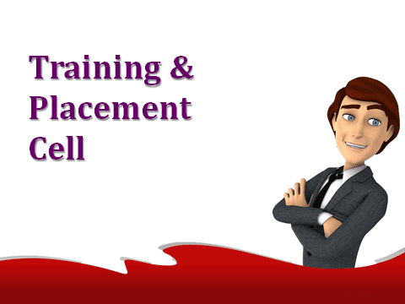

1. **Virtual workshop on AI for students: Build Your Own Generative AI Model"**

**Event Overview:**

The Training and Placement Cell of RCPET’s IMRD has organized virtual Workshop: "AI for Students: Build Your Own Generative AI Model" On July 6th, 2024. The event aimed to provide students with a comprehensive understanding of Generative Artificial Intelligence (AI), equipping them with practical skills that are increasingly valuable in the current job market. The workshop was specifically designed for BCA, MCA, and Integrated MCA (IMCA) students, with a total of 267 participants across various year groups.

The session was led by **Mr. Trivikrama Kothinti**, an AI expert and alumnus of IIT Delhi.

The workshop covered the following key topics:

1. Students were introduced to the concepts of ANI and AGI, understanding the scope and limitations of each.
2. A detailed explanation of how analytical AI differs from generative AI, highlighting the unique capabilities and use cases of generative models.
3. The session included real-world examples and applications of AI, demonstrating how AI is transforming various industries.
4. Students learned how to create prompts that guide AI models to produce accurate and relevant outputs.
5. The workshop also addressed the limitations and ethical considerations of using generative AI, ensuring students are aware of the challenges and responsibilities involved.

The workshop was highly successful, with 267 students actively participating and engaging with the content. The participants gained valuable insights into the world of Artificial Intelligence, specifically in the area of generative AI.



**Mr. Trivikrama Kothinti delivered lecture on Own Generative AI model**

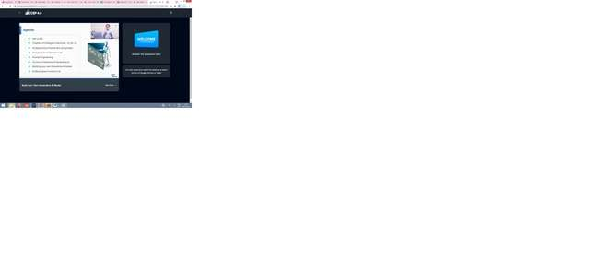

**Different points discussed in meeting by Resource person**

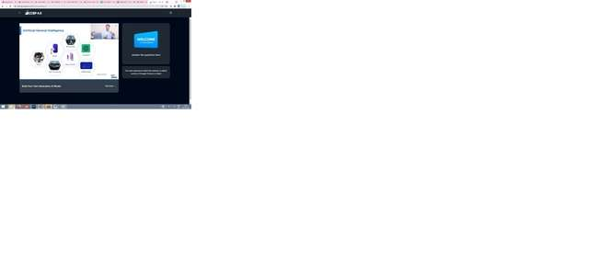

**Importance of AI was discussed by Resource person**

1. **Campus Credential 10 Days Employability Development Program MCA 2025 Batch**

Training and Placement Cell of RCPET’s IMRD was organized 10 Days Employability Skill Development Program for MCA 2025 Batch from 18h July to 27th July in institute every day from 9am to 5pm. During these 10 days students were trained on following skills:

* Aptitude Skills
* Logical Reasoning
* Reading Comprehension
* Communications Skills
* Interview Skills
* Group Discussion
* Soft Skills
* Personality Development.

Mr. Sumit Gaikwad from Pune was the resource person who trained students on the Aptitude and logical reasoning skills. Sir Has covered different topics in aptitude like Time, Distance, speed, Ratio and Proportion, Mean, Mode, Median, Profit and loss, Data interpretation etc.

Mrs. Sayali Saptarshi from Mumbai was resource students on communication and Soft skills in which he covered many topics like resume writing, Vocabulary, Interview Skills, Personality development, Group Discussion etc.

Total 104 students from MCA final year was participated in event. Training and placement officer Mrs. Archana Jade, Mrs. Sapana S. Yeshi and PG faculties gave their great support to make this event successful.

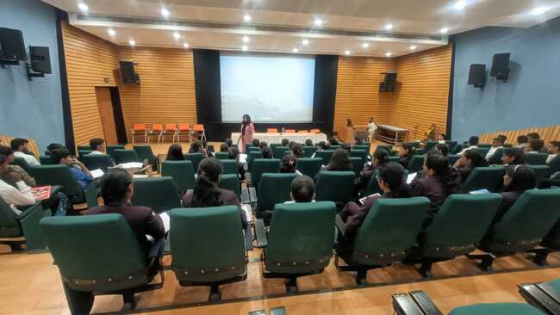

**Soft Skills session by Trainer Mrs. Sayali Saptarshi**

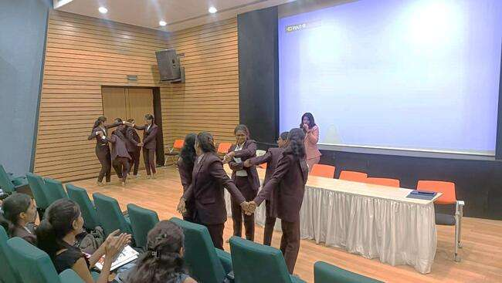

**Students participated in the group activity in the training**

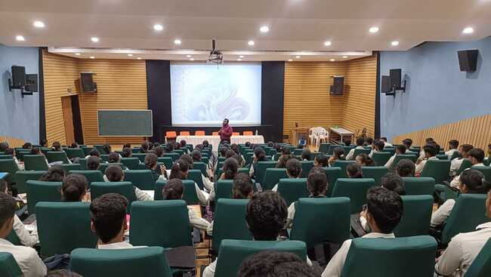

**Aptitude training by Trainer Mr. Sumit Gaikwad**

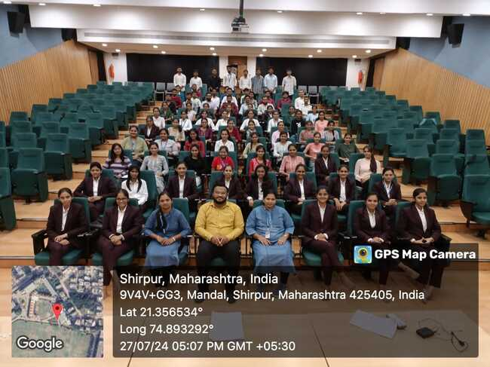

**Final Year MCA Students participated in the training with Trainer Mr. Sumit Gaikwad and team T&P**

1. **Campus Credential 10 Days Employability Skills Development Program BCA 2025 Batch**

Training and Placement Cell of RCPET’s IMRD was organized 10 Days Employability Skill Development Program for BCA 2024 Batch from 22nd August to 2nd September 2024 in institute every day from 9am to 5pm. During this 10 days program students were trained on following skills:

* Aptitude Skills
* Logical Reasoning
* Reading Comprehension
* Communications Skills
* Interview Skills
* Group Discussion
* Soft Skills
* Personality Development.

Mr. Sumit Gaikwad from Pune was the resource person who trained students on the Aptitude and logical reasoning skills. Sir Has covered different topics in aptitude like Time, Distance, speed, Ratio and Proportion, Mean, Mode, Median, Profit and loss, Data interpretation etc.

Mr. Sapna Sood from Pune was resource person who trained students on communication and Soft skills in which he covered many topics like resume writing, Vocabulary, Interview Skills, Personality development, Group Discussion etc.

Total 156 students from Third Year BCA were participated in event. Training and placement officer Mrs. Archana Jade, Mrs. Sapana Yeshi, Mr, Kedar Apte, Kirtika Behere, Mrs. Jyotsna Mali and BCA faculties gave their great support to make this event successful.

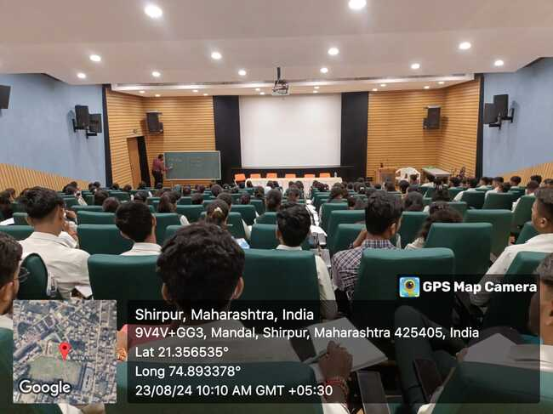

**Aptitude training by Trainer Mr. Sumit Gaikwad**

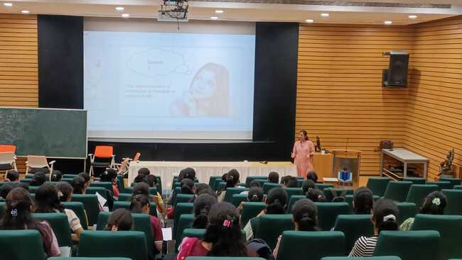

**Soft Skills Session by Trainer Mrs. Sapana Sood**

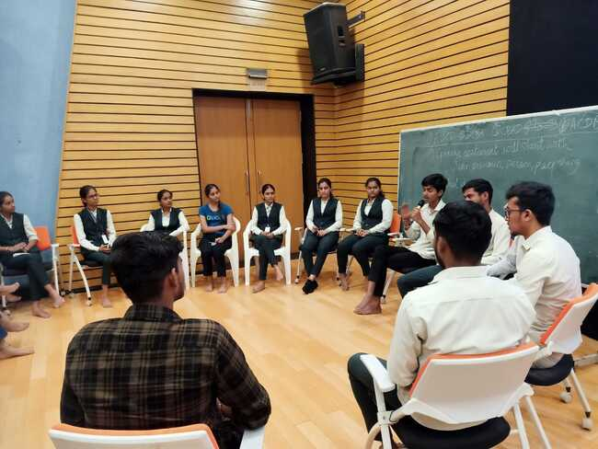

**Students participated in the group activity training**

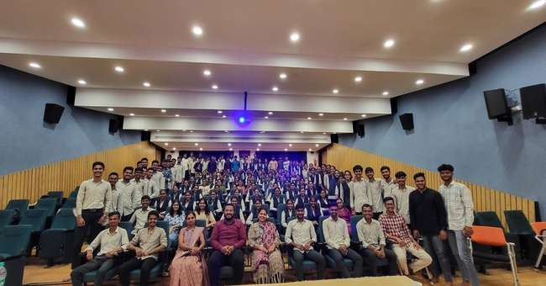

**Third Year BCA Students participated in the training with Trainer Mr. Sumit Gaikwad and team T&P**

1. **Campus Credential: 10-Day Employability Skills Development Program For BBA and BMS 2025 Batch**

The Training and Placement Cell of RCPET’s IMRD organized a 10-Day Employability Skills Development Program for the BBA and BMS 2025 Batch from 30th September to 9th October 2024 at the institute, conducted daily from 9:00 AM to 5:00 PM.

During this 10-day program, students were trained in the following skills:

* Aptitude Skills
* Logical Reasoning
* Reading Comprehension
* Communication Skills
* Interview Skills
* Group Discussion
* Soft Skills
* Personality Development

Mr. Sachin Bhosale from Pune was the resource person who trained the students in Aptitude and Logical Reasoning. He covered various topics such as Time, Distance, Speed, Ratio and Proportion, Mean, Mode, Median, Profit and Loss, Data Interpretation, and more.

Ms. Shruti Mishra from Mumbai was the resource person for Communication and Soft Skills. She covered several key topics including Resume Writing, Vocabulary Building, Interview Skills, Personality Development, Group Discussion, and more.

A total of 100 students from Third Year BBA and BMS actively participated in this program.

The event was successfully conducted with the continuous support of Training and Placement Officer Mrs. Archana Jade, Mrs. Sapana Yeshi, Dr. Yogesh Sethiya, Mr. Kaustubha Sawant, Mr. Vijay Garge, and the BBA faculty team.

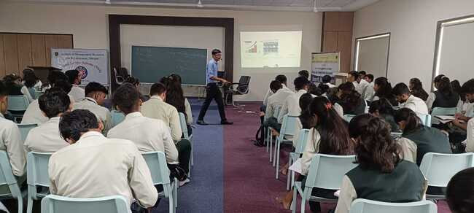

**Mr. Sachin Bhosale conducting session on Aptitude**

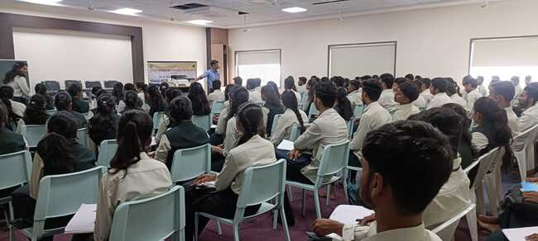

**Students participated in aptitude training**

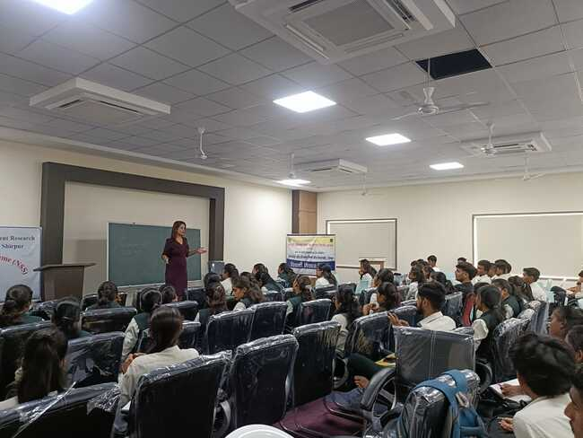

Ms. Shruti Mishra conducting communication skill session

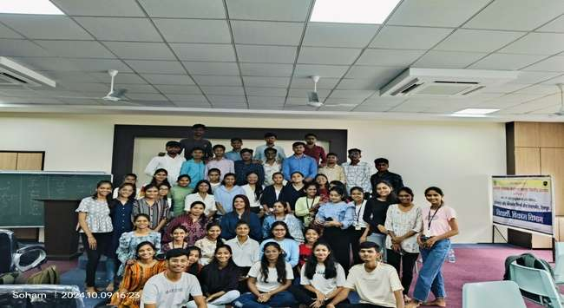

**Students participated with Trainer and T&P team**

1. **2-day workshop on "Exploring Java: Basic to Advanced**

The Training and Placement Cell of RCPIMRD successfully conducted a 2-day workshop on "Exploring Java: Basic to Advanced" on 14th and 15th October 2024. The event, organized for MCA 2nd year and IMCA 5th year students, Mr. Yogesh Sonwane, Technical Lead at Geniateq Pvt. Ltd., Pune, was invited as the resource person.

A total of 82 students participated actively, engaging in both fundamental and advanced Java programming sessions.

The workshop began with a welcome and felicitation of Mr. Yogesh Sonwane by Mr. Manoj Behere. The workshop covered essential topics such as:

* Java Syntax and Control Structures
* Object-Oriented Programming Concepts
* Exception Handling and File Operations
* Multi-threading and Advanced Java Frameworks etc
* Java Technical Interview Question

Students appreciated the hands-on exercises, which provided a deeper understanding of Java concepts and real-world applications.

The workshop was designed to enhance students' technical skills and provide them with practical knowledge to meet industry demands.

The success of the workshop was ensured through the dedicated efforts of

* Mr. Manoj Behere – Head of MCA Department
* Mrs. Archana Jade – Training and Placement Officer
* Mrs. Sapana Yeshi – Assistant Training and Placement Officer

Their meticulous planning and coordination were crucial in making the program a success.

The participants expressed their gratitude for the opportunity to learn from an industry expert. They found the sessions engaging and insightful, helping them build confidence in their programming abilities.

The Training and Placement Cell extended its heartfelt thanks to Mr. Yogesh Sonwane for his valuable contribution and to the students for their active participation.

This workshop reflects RCPIMRD’s commitment to empowering students with industry-relevant skills and preparing them for future career opportunities.

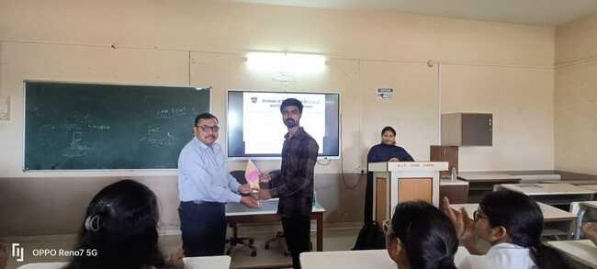

**Head of MCA department Mr. Manoj Behere Felicitating Mr. Yogesh Sonwane**

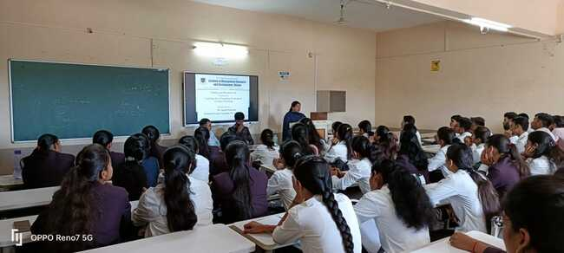

**Training and Placement officer Archana Jade introducing Mr. Yogesh Sonwane**

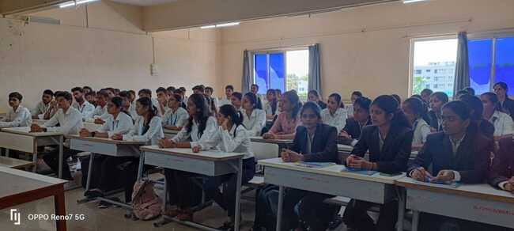

**MCA and MCA integrated students participated in event**

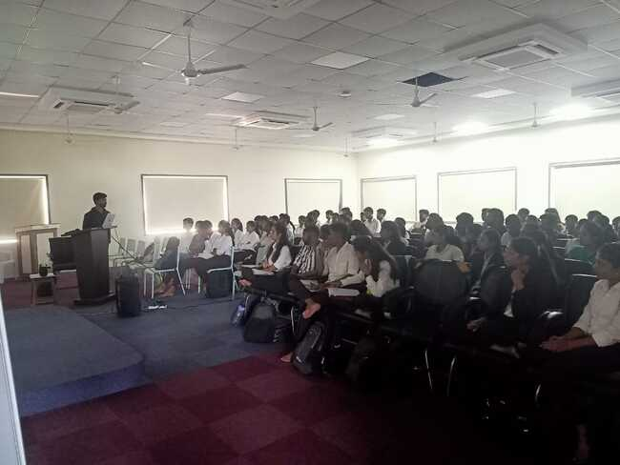

**Mr. Yogesh Sonwane Delivering session on Advance Java.**

**5 - Eminence Skill Development Training for MCA 1st Year Students**

**Date of Training:** November 25th to November 30th, 2024  
**Venue:** RCPET’s IMRD  
**Participants:** 154 MCA 1st Year Students  
**Resource Person:** Mr. Kalyan Kumar

An **Eminence Skill Development Training** was organized at RCPIMRD for the MCA 1st-year students, held from **November 25th to November 30th, 2024**. The training aimed to enhance the **communication skills** of the students through a combination of theoretical concepts and practical, activity-based learning. A total of **154 students** participated in the event, which proved to be both educational and motivational.

The training was conducted by **Mr. Kalyan Kumar**, a seasoned trainer in communication skills. His rich experience and engaging teaching style enabled students to grasp various communication techniques effectively. Mr. Kumar’s presence and active involvement in the sessions were key to the overall success of the training program.

The training was designed to improve the communication skills of students by covering essential topics such as **tenses**, **vocabulary**, **grammar skills**, **presentation techniques**, and activities to overcome **stage fear**. Through interactive sessions and practical exercises, students learned how to use grammar and tenses effectively, expand their vocabulary, and communicate with confidence.

The training session was honored by the esteemed presence of **Ms. Resha Patel** and **Hon. Director Dr. Vaishali Patil**, head of department **Mr. Manoj Behere** who attended the concluding session. **Ms.**

**Resha Patel** delivered motivating speech, inspiring the students to utilize the skills they acquired during the training to enhance their future prospects.

The success of the training program can be attributed to the dedicated efforts of several individuals. **Mr. Manoj Behere**, the **Head of the MCA Department**, expressed his sincere gratitude to the resource person, **Mr. Kalyan Kumar**, for his dedication and expertise in conducting the sessions.

**Mrs. Archana Jade**, the **Training and Placement Officer and Mrs. Sapana S. Yeshi**, the **Assistant Training and Placement Officer**, All MCA and IMCA faculties played a vital role in organizing the event and ensuring its smooth execution.

This training proved to be an invaluable experience for the students, who benefited from both the theoretical knowledge and practical exercises. The training concluded with a note of appreciation for the students’ active participation and a commitment to continue developing communication skills to excel in their careers.

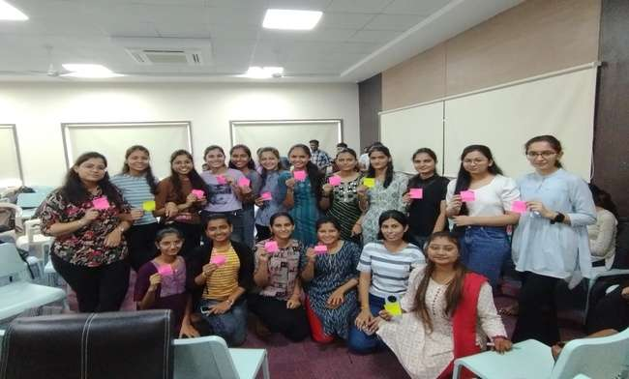

**Students participated in team activity**

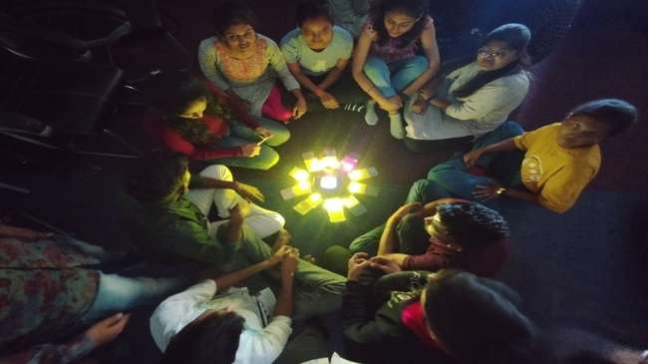

**Learning Through Fun for Students**

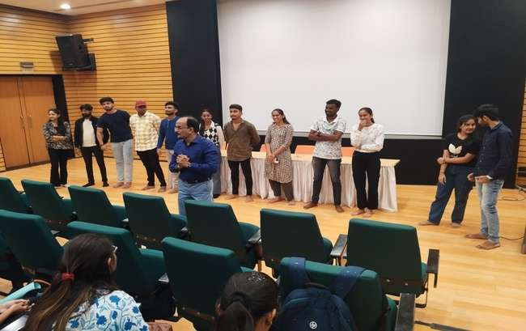

**Mr. Kalyankumar V. Facilitating the session**

**6- Campus Placement Drive Bullet Healthcare Services, Shirpur**

The Training and Placement Cell of RCPET’s IMRD proudly organized a campus placement drive in association with Bullet Healthcare Services, Shirpur on 23rd Nov 2024.

This initiative aimed to provide career opportunities for MCA final-year students while strengthening the institute’s ties with the industry.The event was graced by the esteemed team from Bullet Healthcare Services, including Mr. Vikas Mali, Chief Operating Officer (COO); Ms. Nidhi Gujrathi, Chief Technology Officer (CTO); Mr. Ronak Nikam, Engineer; and Mr. Nikhil Mali, an MCA-I alumnus from the 2020 batch. The dignitaries were warmly welcomed and felicitated by Mr. Manoj Behere, Head of the MCA Department, in recognition of their continued support for the institute’s placement initiatives.

A total of 35 students participated enthusiastically in the drive. The recruitment process began with a technical offline test, assessing the candidates' core technical competencies. Following the test, 25 students were shortlisted for the next stages of the selection process. The recruitment team then

conducted in-depth technical and HR interviews, evaluating students on various parameters, including technical skills, problem-solving abilities, and communication skills. After thorough assessment, 5 deserving students were selected for key positions at Bullet Healthcare Services.

The selected candidates are:

* Mr. Laxmikant Patil
* Mr. Pradyumna Marathe
* Mr. Kalpesh Mahajan
* Ms. Rashmi Deore
* Mr. Prem Mahajan

The successful execution of this placement drive was the result of collective efforts. Mrs. Archana Jade, TPO and Assistant TPO Mrs. Sapana Yeshi, played a pivotal role in organizing the event, coordinating with the company, and ensuring the seamless flow of activities.

The contribution of the MCA department faculty members was equally commendable. Their continuous guidance and mentorship prepared students to face challenges during the placement process confidently. Special thanks are extended to Mr. Manoj Behere, Head of the MCA Department, for his leadership and support throughout the initiative.

This placement drive was not only a significant career milestone for the selected students but also a testament to RCPET’s IMRD’s commitment to bridging the gap between academia and industry. The Training and Placement Cell extends its heartfelt gratitude to the team from Bullet Healthcare Services for their collaboration and for providing students with an opportunity to embark on promising career paths. The event concluded successfully, leaving a lasting impact on students and reaffirming the institute’s dedication to excellence in training, skill development, and placement opportunities.

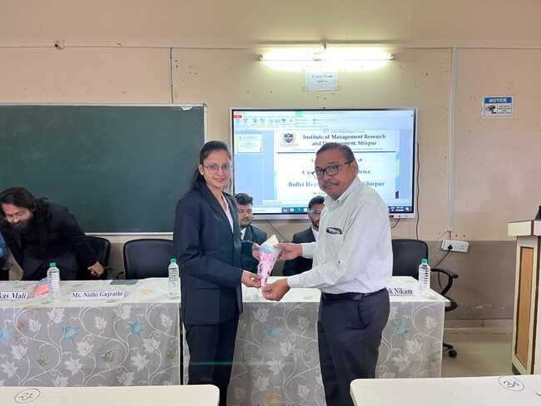

**Mr. Manoj Behere welcomes Ms. Nidhi Gujrathi**

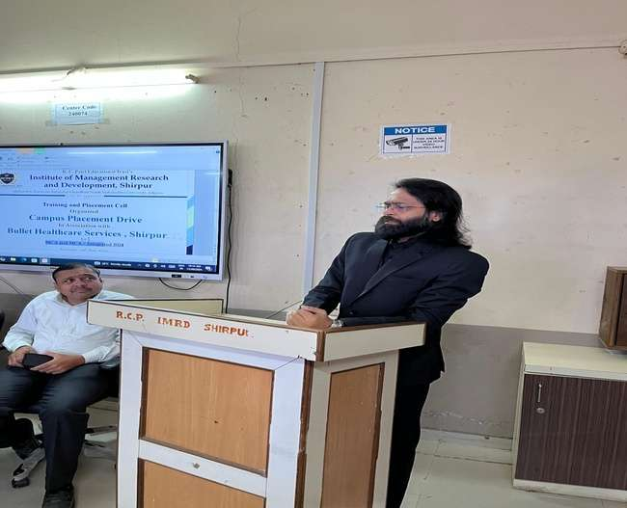

**Mr. Vikas Mali delivering the pre-placement talk**

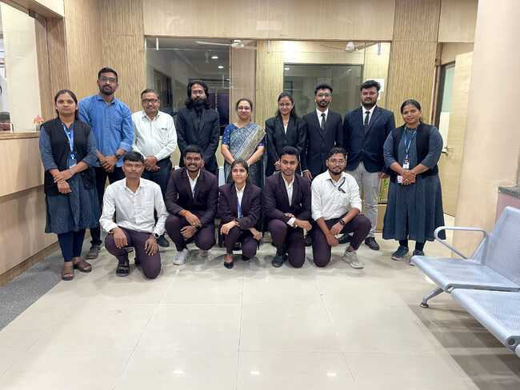

**Students shortlisted with the HR team and dignitaries**

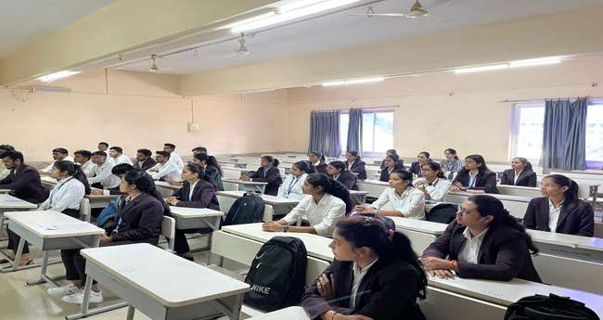

**Students participated in Campus Drive**

**7- Campus Placement Deskcode Solution Pvt. Ltd, Shirpur**

The Training and Placement Cell of R. C. Patel IMRD successfully organized a campus placement drive in collaboration with Deskcode Solution Pvt. Ltd., Surat, on the 17th and 18th of December 2024. The event witnessed enthusiastic participation, with a total of 95 students competing for placement opportunities.

The drive was graced by the esteemed presence of Mr. Nikunj Kakadiya (CEO), Mr. Ankur Patel (CTO), Mr. Naimish Joshi (Team Leader), Mr. Nilesh Jinjala (Developer), and Mr. Jaydeep Sorathiya (Developer), who conducted the placement process.

The placement drive commenced with an aptitude test, where 36 students were shortlisted. The second round, a machine test, further shortlisted 20 students for the final stage: technical interviews. The technical interviews are scheduled to be held on the second day of the drive, December 18th, starting at 9:30 AM. Heartiest congratulations to the five MCA students who were shortlisted during the drive: Mr.Pankaj Patil, Mr.Kaushal Patil, Mr.Gaurav Sonawane, Mr.Bhupesh Patil, and Mr.Akshay Patil. Mr. Manoj Behere, Head of Department, along with Dr. Manoj Patel, welcomed and felicitated the guests from Deskcode Solution Pvt. Ltd. The guests expressed their gratitude and appreciation for the institute’s efforts in organizing such a well-structured placement drive and commended the institute’s commitment to student development.

The success of this event was made possible through the special efforts of Mrs. Archana Jade (Training and Placement Officer), Ms. Sapana Yeshi (Assistant Training and Placement Officer), the MCA faculty members, and the non-teaching staff. Their dedication ensured smooth coordination and a well-executed event. The Training and Placement Cell extends its heartfelt thanks to the team from Deskcode Solution pvt. Ltd. for their valuable time and efforts and wishes all participating students the very best in their future endeavours.  
  
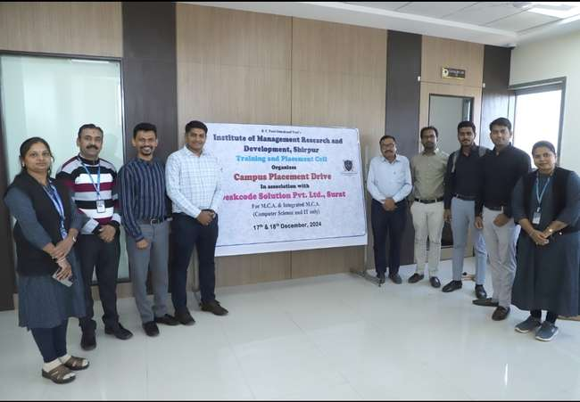 **Deskcode Solutions Pvt. Ltd. conducted a campus placement drive at R. C. Patel IMRD**

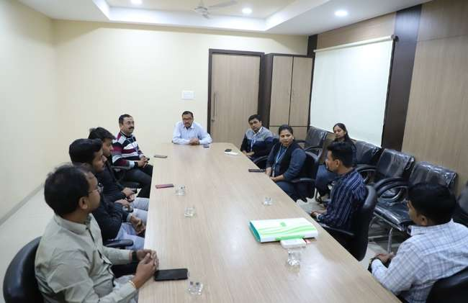 **Deskcode Solutions team during a productive meeting in the conference room**

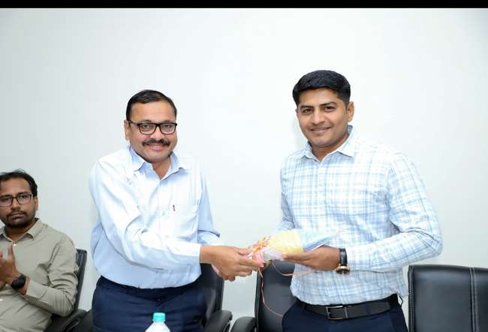  
**Mr. Nikunj Kakadiya, CEO of Deskcode Solutions, being felicitated by HOD Mr. Manoj Behere**

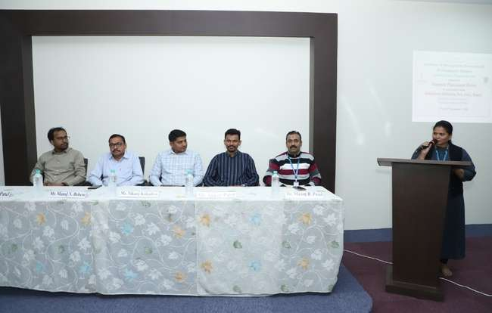  
**The Training and Placement Officer warmly welcomed and introduced the esteemed guests.**  
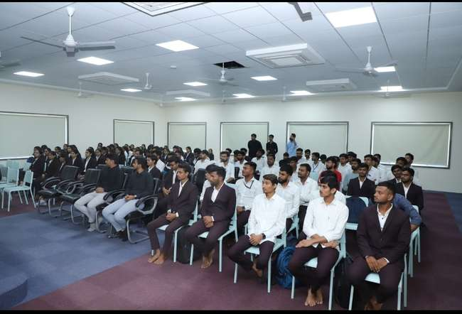

**MCA and MCA Integrated students actively participating in the campus placement drive**

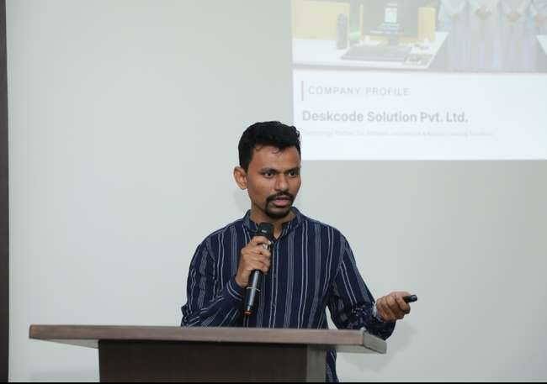

**Mr. Ankur Patel, CTO of Deskcode Solutions, delivering the pre-placement talk.**  
  
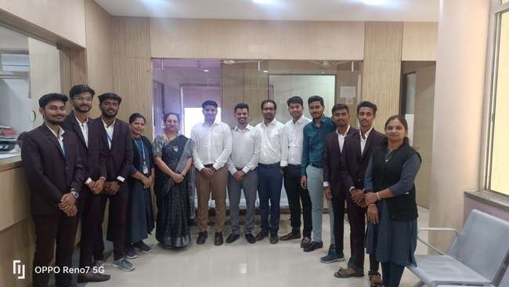  
**Shortlisted candidates with the recruitment team and Hon. Director Dr. Vaishali Patil.**

**8. Campus Placement Drive Organized by R.C. Patel IMRD in Collaboration with CMOTS Technologies Pvt. Ltd, Mumbai**

The Training and Placement Cell of R.C. Patel Institute of Management Research and Development, Shirpur, successfully organized a campus placement drive in collaboration with CMOTS Pvt. Ltd., Mumbai, on December 19th and 20th, 2024.

The event was honoured by the esteemed presence of Mr. Gopal Walhe, General Manager of CMOTS Pvt. Ltd., and an accomplished alumnus of the MCA batch (2001-2004). Dr. Manoj Patel warmly welcomed and felicitated Mr. Gopal Walhe, expressing gratitude for his active involvement in the placement drive and applauding his efforts as a proud alumnus.

In his address, Mr. Gopal Walhe conveyed his appreciation for the institute’s well-organized event and its unwavering commitment to student development and career preparedness.

The placement process commenced with technical interviews over two days, during which 51 candidates were shortlisted based on their resumes. Following rigorous assessments, 12 candidates were further selected for a final virtual technical interview conducted by the Project Management team of CMOTS Pvt. Ltd., Mumbai, on December 24th.

Ultimately, the top five candidates were offered positions with a starting pay package of 2.4 LPA in the following roles:

* **Ms. Kumud Bari** - ASP.Net Developer
* **Ms. Sayali Saner** - Database Developer
* **Mr. Chetan Shimpi** - ASP.Net Developer
* **Ms. Jayashri Firake** - Database Developer
* **Mr. Prasad Patil** - Database Developer

The success of this event is attributed to the diligent efforts of Mrs. Archana Jade (Training and Placement Officer), Ms. Sapana S. Yeshi (Assistant Training and Placement Officer), the MCA faculty members, and the non-teaching staff, whose dedication ensured seamless coordination and execution.

Director Dr. Vaishali Patil, Mr. Manoj Behere (Head of MCA and MCA Integrated), Dr. Manoj Patel (IQAC Coordinator), and Dr. Tushar Patel extended their heartfelt congratulations to the selected candidates.

The Training and Placement Cell expresses its sincere gratitude to the CMOTS Pvt. Ltd. team for their time, effort, and invaluable support and wishes all participating students great success in their future endeavours.

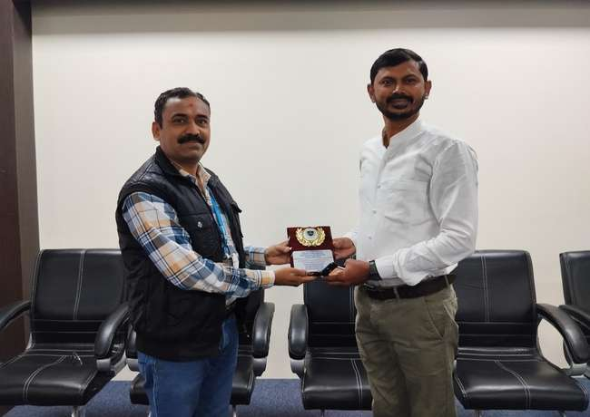  
  
 **Dr. Manoj Patel sir felicitating Mr. Gopal Walhe**

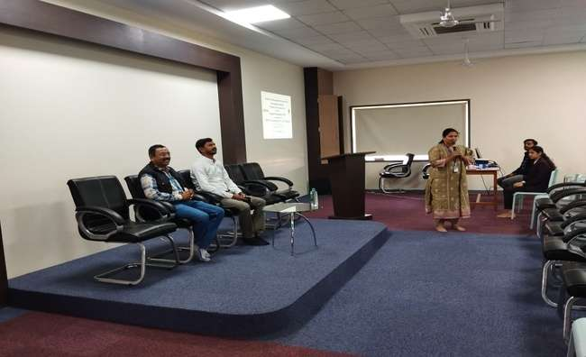

**Mrs. Archana Jade Training and Placement officer welcome and introduced the guest**

**9. Competitive Exam Orientation Program**

The Training and Placement Cell of RCPET’s Institute of Management Research and Development (IMRD) organized a **Competitive Exam Orientation Program** on **December 26, 2024**, for **Third Year BCA (TYBCA)** and **Third Year BBA (TYBBA)** students within the institute premises.

The objective of the session was to create awareness among students about various **competitive examinations** available after graduation and guide them toward structured career planning. The session focused on exams such as CAT, CET, GATE, IBPS, SSC, UPSC, and other government and private sector opportunities, encouraging students to prepare early and strategically.

The session was led by **Mrs. Archana Jade** and **Mrs. Sapana Yeshi**, who served as the **resource persons** for the event. Both shared their valuable knowledge and insights on:

* The types and importance of competitive exams.
* Eligibility criteria, exam patterns, and key preparation strategies.
* Time management techniques and effective study plans.
* Building a career roadmap aligned with individual interests and goals.

Their session was highly interactive and motivational, encouraging students to ask questions and gain clarity on their career paths. Students were inspired to explore various domains and take initiative in enhancing their employability through consistent preparation and informed choices.

A total of **100 students** actively participated in the session and expressed their appreciation for the practical guidance and motivation provided.

The success of this program was made possible with the support of **Mr. Tushar Patel**, Head of the UG Department, and the collective efforts of UG faculty members, who ensured smooth coordination and student engagement.

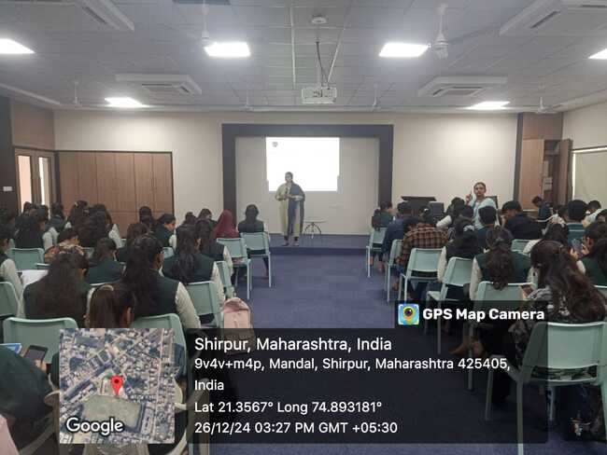  
Mrs. Archana Jade and Mrs. Sapana Yeshi guiding students on competitive exam

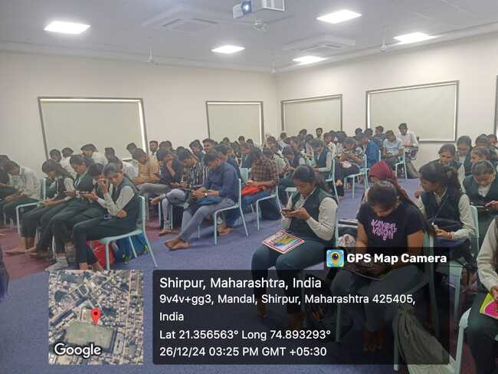

Students attended competitive exam session

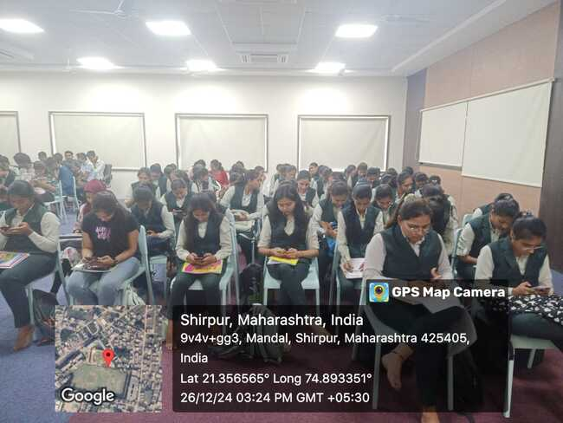

Students go through via different portal

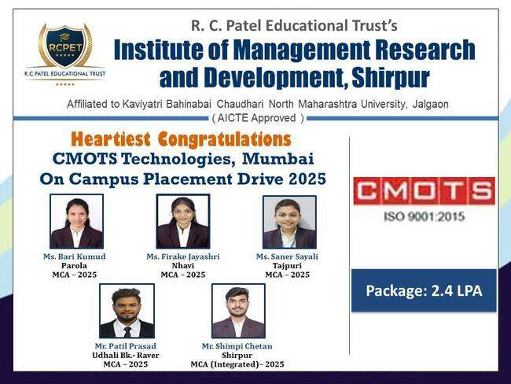

**Students Placed in CMOT Technology Pvt Ltd, Mumbai**

**9. Report** - **15-day Skill Development Program for TYBBA and TYBMS**

The Training and Placement Cell of the institute organized a 15-day Skill Development Program (SDP) in collaboration with Infosys, aiming to enhance students’ communication, employability, and problem-solving skills. The institute remains committed to providing students with holistic development opportunities beyond academics through various workshops, seminars, and training programs.

The Infosys Employability Training Program was conducted for two batches of BBA and BMS students, focusing on aptitude and soft skills crucial for career readiness. This marked the sixth consecutive year of collaboration with Infosys, ensuring continuous skill enhancement for students.

The training sessions were conducted as follows:

* Batch 1: 5th January 2025 – 23rd January 2025 (62 students)
* Batch 2: 20th January 2025 – 5th February 2025 (65 students)

Total 127 students participated in the program. The resource persons included Ms. Priya Rathod (Soft Skills Trainer, Mumbai) and Mr. Shant Kumar (Aptitude Trainer, Bangalore). The training covered vita

l topics such as Communication Skills, Business Writing, Email Writing, Grammar, Interview Techniques, Resume Writing, Analytical Problem-Solving, Group Discussions, Telephone Etiquettes, and Customer Service Skills. Various interactive activities, discussions, and practical exercises ensured active student engagement and learning.

The training methodology involved interactive sessions, group discussions, problem-solving exercises, and mock interviews, providing students with hands-on experience and corporate exposure. The program successfully enhanced students' confidence, aptitude skills, and communication abilities, preparing them for job opportunities in top IT companies like TCS, Infosys, Capgemini, Cognizant, and Persistent.

At the conclusion of the program, books and participation certificates were distributed as a token of appreciation. Students shared positive feedback, expressing gratitude towards the institute and Infosys for the valuable training experience.

The success of this initiative was made possible through the efforts of Head of the Department Dr. Tushar Patel, Training and Placement Officer Prof. Archana Jade, Mrs. Sapana Yeshi, and Parent Teachers of TYBBA and TYBMS Dr. Yogesh Sethiya, Mr. Kaustubh Sawant, and Mr. Vijay Garge, along with faculty members from the UG department. Their dedication ensured a well-organized and impactful training experience for the students.

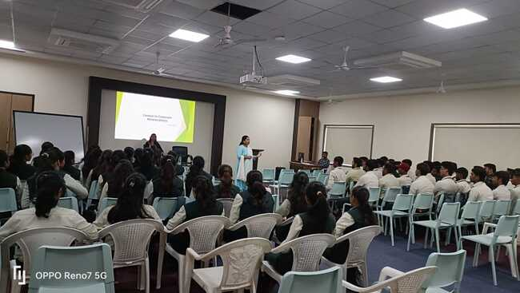

**Inauguration of 15 – days Skill Development Program**

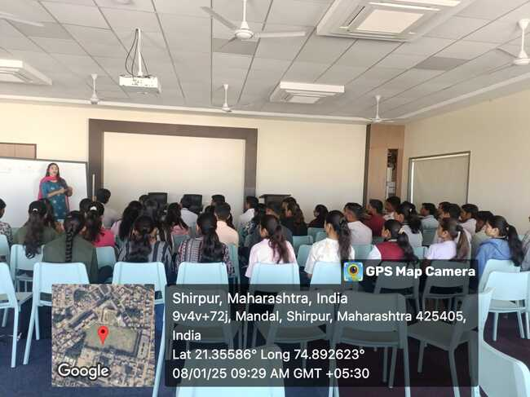

Soft skills Session by trainer Miss. Priya Rathod

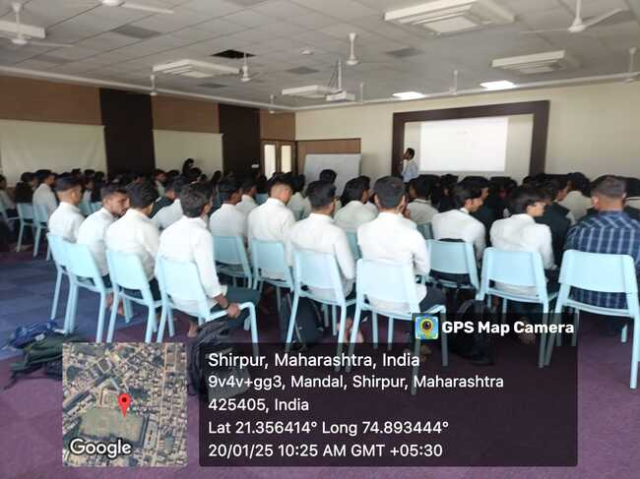

Aptitude session by Trainer Mr. Shant Kumar

**10. Two days Financial Literacy Program by NSE**

The **Training and Placement Cell** of the institute successfully organized a **two-day Financial Literacy Program** on **20th and 21st January 2025** for students of **Second Year BBA, BMS, and BCA**. The program aimed to enhance students' understanding of **financial management, investment strategies, and economic decision-making**, equipping them with essential financial knowledge to make informed financial decisions in their personal and professional lives.

A total of **297 students** participated in the program:

* **BBA:** 92 students
* **BMS:** 47 students
* **BCA:** 158 students

The sessions were conducted by esteemed resource persons **Dr. Svetlana Tatuskar** and **Mrs. Sarika Lohana** from **NSE (National Stock Exchange)**. The training covered crucial topics such as **personal finance management, stock market basics, investment planning, risk assessment, financial decision-making, and economic awareness**. The sessions were designed to be interactive, incorporating **real-life case studies, group discussions, practical exercises, and Q&A sessions** to ensure students' active engagement and understanding.

Students were introduced to fundamental concepts of **budgeting, savings, investment avenues, and the role of financial institutions in wealth creation**. Special emphasis was placed on **understanding risk versus return, mutual funds, stock market dynamics, and the significance of credit scores**. The resource persons also guided students on how to make **informed financial decisions, develop smart investment habits, and avoid common financial pitfalls**. The inclusion of **live market analysis and simulations** helped students relate theoretical concepts to real-world financial scenarios.

The success of this initiative was made possible through the dedicated efforts of **Head of the Department Dr. Tushar R. Patel, Training and Placement Officer Prof. Archana M. Jade, Mrs. Sapana S. Yeshi, and Parent Teachers**, along with faculty members from the **UG department**. Their commitment and meticulous planning ensured a well-structured and impactful learning experience for the students. The support from the institute’s administration and faculty played a crucial role in organizing and executing the event smoothly.

At the conclusion of the program, students expressed their appreciation for the insightful sessions, recognizing the significance of financial literacy in personal and professional life. Many students highlighted how the program helped them understand **how to manage their finances efficiently, plan their investments, and set long-term financial goals**. The initiative proved to be a valuable addition to the institute’s continuous efforts in preparing students for real-world financial challenges.

The **Training and Placement Cell** remains committed to equipping students with the necessary skills and knowledge required for their holistic development. This Financial Literacy Program marked another successful step toward empowering students with essential life skills that will guide them in making sound financial decisions in the future.

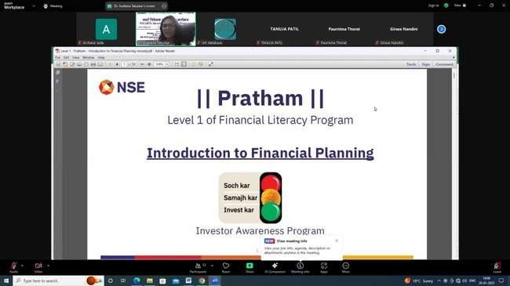

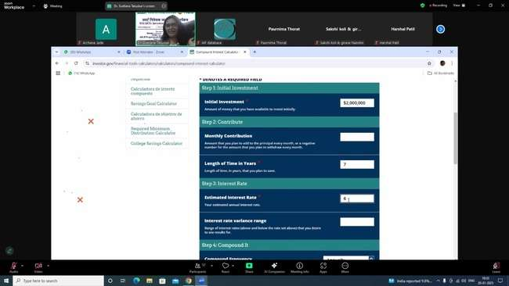

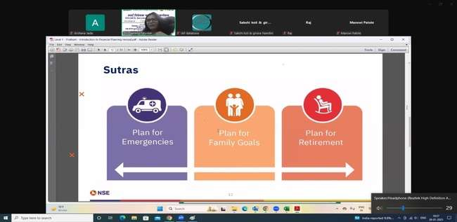

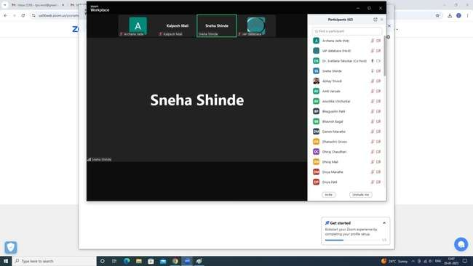

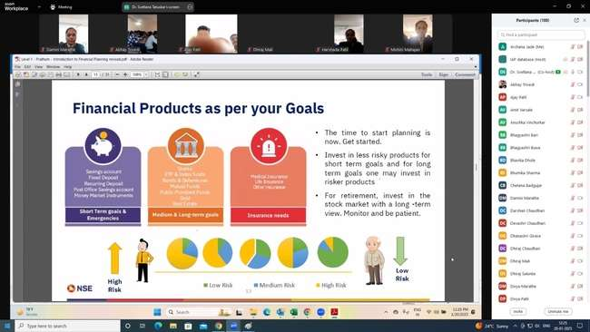

11**. Industry Visit at Infosys Pune**

Report: The Training and Placement Cell of RCPET’s IMRD organized an industrial visit to **Infosys, Pune** on **22nd February 2025**, where **25 students** from TYBBA and SYBBA participated, accompanied by **Mrs. Archana Jade (TPO)** and **Mrs. Sapana Yeshi (Assit. TPO)**. The visit aimed to provide students with real-world exposure to the corporate environment and bridge the gap between academic knowledge and industry practices. Upon arrival, students were given a guided tour of the Infosys campus, known for its world-class infrastructure and eco-friendly surroundings. The Infosys team conducted informative sessions, sharing insights on company operations, emerging technologies, project management, and the essential skills needed to thrive in the IT sector. To enhance engagement, the team organized interactive games and team-building activities, fostering collaboration and problem-solving

skills among the students. A delicious lunch was also arranged by the Infosys team, adding a personal touch to their warm hospitality.

Post the industrial visit; students explored **Prati Shirdi** and **Dehugaon**, where they experienced cultural landmarks, making the trip both educational and enjoyable. The visit proved to be a valuable learning experience, helping students gain clarity about industry expectations, boosting their confidence, and motivating them to align their academic skills with future career goals. The Training and Placement Cell extends heartfelt gratitude to the **Infosys Pune** team for their exceptional support and hospitality.

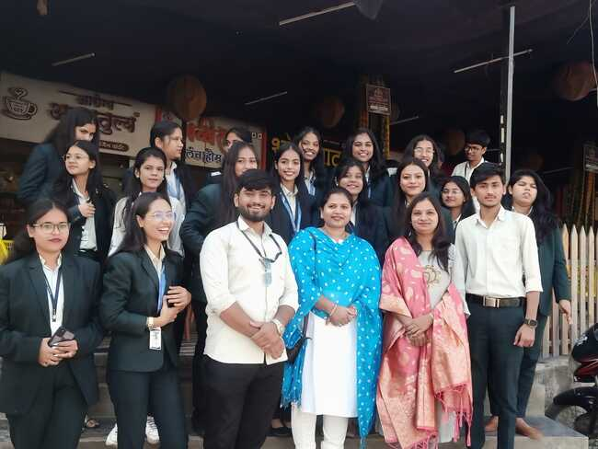 **Geared Up for an Insightful Industry Visit!**

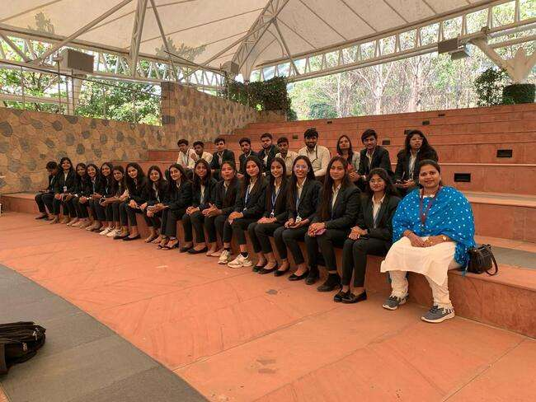

**Students at Infosys Campus together with Faculty Members**

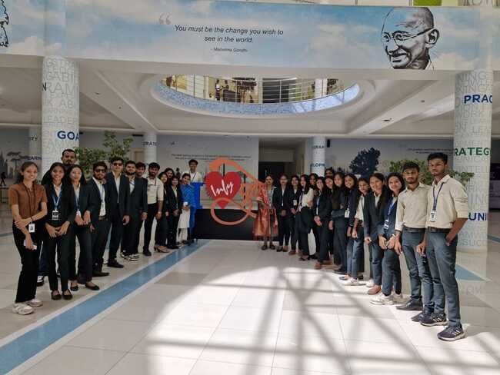

**Exploring Infosys Campus**

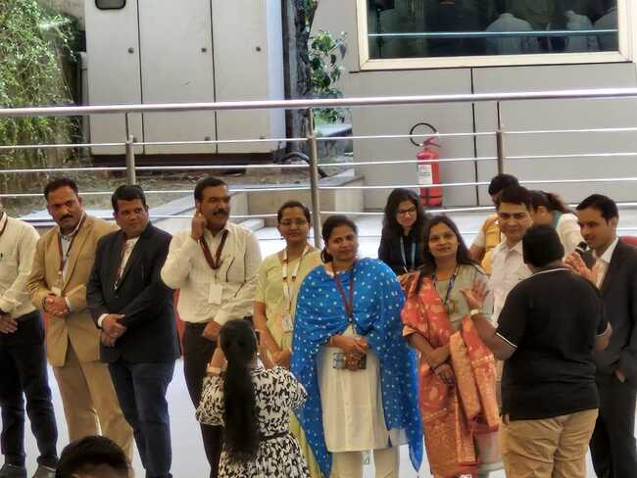 **Active participation of faculty members at Industry visit**

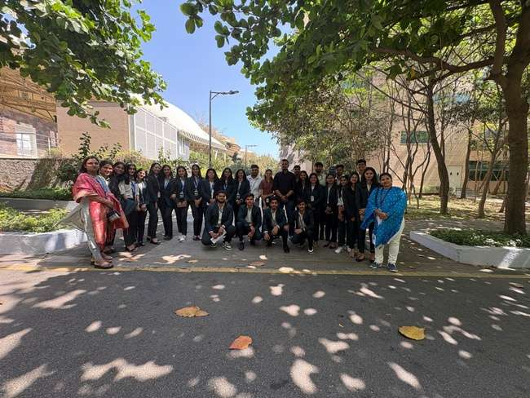 **Alumni Meet at Infosys, Pune**

**12. Report on Training on “Effective Use of LinkedIn for Career”**

**Date of Training:** March 3rd, 2025  
**Venue:** RCPT’s IMRD  
**Resource Person:** Mr. Amogh Ghotaskar, Mumbai

A training session on “Effective Use of LinkedIn for Career” was successfully organized at RCPIMRD on March 3rd, 2025, for the final-year students of BCA, BBA, MCA 1st Year, and IMCA 4th Year. The objective of the session was to educate students on the significance of LinkedIn as a professional networking platform and how it can be effectively used to shape their career paths.

The training was conducted by Mr. Amogh Ghotaskar from Mumbai, an expert in career development and professional branding. Mr. Ghotaskar brought with him a wealth of knowledge and industry insights, which he delivered in an engaging and interactive manner. The training was divided into two sessions to accommodate different student groups:

|  |  |  |  |
| --- | --- | --- | --- |
| **Session** | **Class** | **Time** | **Total Participants** |
| 1 | BCA,BBA & BMS 3rd Year Students | 11:30 AM to 1:30 PM | 202 |
| 2 | MCA 1st Year & IMCA 4th Year Students | 2:00 PM to 4:00 PM | 198 |

Throughout the session, Mr. Ghotaskar guided the students on creating a strong and professional LinkedIn profile, developing a personal brand, building an effective network, and exploring job and internship opportunities on the platform. Live demonstrations, tips on writing impactful summaries and experience descriptions, and strategies to enhance visibility were some of the key highlights of the training.

The session was graced by the presence of Hon. Director Dr. Vaishali Patil, Mr. Manoj Behere, Head of the Department MCA and IMCA, Dr. Tushar R. Patel, Head of the UG Department, Dr. Manoj Patel, IQAC Co-ordinator, Training and Placement Officer Mrs. Archana Jade, and Assistant Training and Placement Officer Mrs. Sapana S. Yeshi, along with faculty members from all concerned departments. Their support and guidance were instrumental in the smooth execution of the event.

The Parent Teachers of the respective classes also contributed significantly to the coordination and smooth conduct of the sessions. Their involvement helped ensure student participation, time management, and discipline throughout the training.

The event was anchored by Mrs. Sapana S. Yeshi, who also proposed the vote of thanks at the end of the session, expressing heartfelt gratitude to the resource person, dignitaries, organizing team, and students for their active participation and support.

The session received an overwhelming response from the students, who actively participated and interacted with the resource person. The training not only helped students understand the strategic use of LinkedIn but also motivated them to present themselves professionally in the digital space.

Overall, the training program was a valuable experience for students, equipping them with essential skills to establish a strong online professional presence and connect with opportunities in the corporate world.

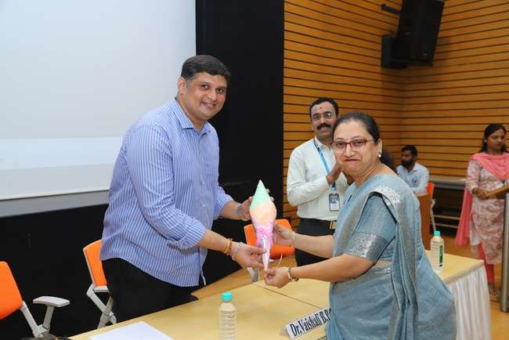

Felicitation of Mr. Amogh Ghotaskar by Hon. Director Dr. Vaishali Patil

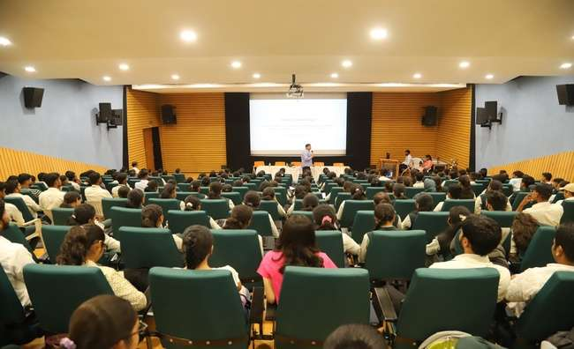

Trainer Mr. Amogh Ghotaskar conducting Session

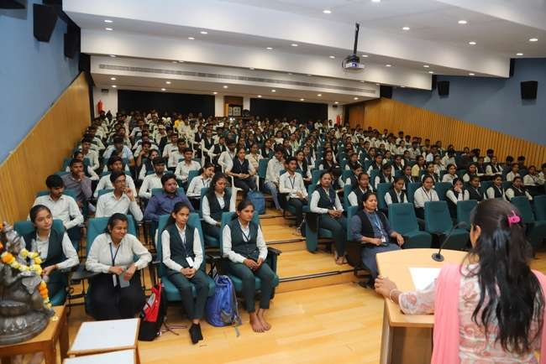

All Participants in the session

**13. Activity Name: - Campus Placement Drive organized by RCPET’s IMRD for TCS BPS, Pune**

**Date: -** 16-05-2025

**Venue: -** S. M. Patel Hall

**Number of Participants: -** 111

**Class**: - BBA, BMS, BA, B.com, BCA, BSc (NMU Region for pass out batches 2023,2024, 2025)

**Objectives: -** To provide all graduate an opportunity to begin their professional careers by connecting them with potential employers, and to facilitate campus recruitment drive.

**Event Highlights:** The Training and Placement Cell of RCPET’s IMRD, has organized pool campus placement drive on 16th May 2025 for TCS BPS, Pune for all NMU region students from BBA, BMS, BA, B.com, BCA, and BSc pass out batches 2023, 2024, 2025. The team of 9 HR and panellists were visited to campus. Mr.Rahul Giri Campus lead and HR , Mr. Kaushtubh Thanewala HR, Ms. Arpita Mohanty HR, Ms. Ashwini Behade HR, Mr.Tanuj Manekar HR , Mr. Yogesh Potdar Senior Managerial panellist , Mr.Mukesh Rai Technical Panellist , Mr.Sunil Chaudhari Technical Panellist,

Mr. Mandar Deshmukh Technical Panellist conducted the process. All the Hr team members of TCS were welcomed and felicitated by presenting the institutes Memento by Assistant director and head of MCA/MCA Integrated department Mr. Manoj Behere sir and IQAC coordinator Dr. Manoj Patel sir.

During the interaction with the TCS BPS team, Mr. Manoj Behere sir and Dr. Manoj Patel sir shared insights about the institute’s consistent academic excellence and highlighted the wide range of value-added activities conducted for student development. They elaborated on how the institute bridges the gap between classroom learning and real-world application through initiatives such as industry-oriented training, skill development programs, and technical workshops.  
  
Ms. Archana Jade TPO extended heartfelt gratitude to the entire TCS BPS team for providing this opportunity to the students of the region and acknowledged the long-standing association between RCPET’s IMRD and TCS over the past 10 years, during which more than 300+ students have been successfully placed in TCS IT and TCS BPS.

Special thanks were extended to Mr. Vishal Rampalle Sir from the TCS team for his continued support regarding student hiring and on boarding processes.

Mr. Rahul Giri Campus lead and HR from TCSBPS was delivered preplacement talk and provided an overview about the selection process, including eligibility verification, aptitude test, interview rounds, and the final selection criteria.

His guidance helped students to better understand the recruitment process and prepare accordingly. A total of 111 Eligible candidates were participated in the drive, undergoing three rounds an Aptitude test, Technical Interview, Managerial Interview and HR interview. In the first round, total 100 candidates were shortlisted. Eventually, 63 candidates cleared all the processes and were selected for final placement with a salary package of 1.9 LPA.

The remarkable success of the TCS BPS placement drive was made possible through the unwavering support and dedication of the faculty members and staff at RCPET’s IMRD. Respected Director Dr. Vaishali Patil Ma’am provided visionary leadership and constant encouragement that set the tone for the entire event. Mr. Manoj Behere, Head of the MCA/IMCA Department and Assistant Director of RCPET’s IMRD, along with Dr. Manoj Patel, IQAC Coordinator, and Dr. Tushar Patel, Head of the UG Department, played instrumental roles in overseeing and guiding the smooth execution of the drive.

Mrs. Archana Jade, Training and Placement Officer, and Mrs. Sapana Yeshi, Assistant Training and Placement Officer, meticulously managed all logistics and coordination efforts, ensuring that every aspect of the event was efficiently handled.The continuous support and mentoring provided by the Training and Placement Committee members – Dr. Amit Patil, Mr. Dinesh Borase, Mr. Vitthal Patil, Mr. Rahul Badgujar, Dr. Priyanka Bhandari, Dr. Asha Patil, Mrs. Rohini Patil, Mrs. Keertika Behere, Mrs. Dhanashree Patil, Ms. Harshada Chaudhari Dr. Yogesh Shethiya, Mr.Kaustubha Sawant and Mr. Vijay Garge were invaluable in guiding and assisting the students throughout the placement process.

Their collaborative efforts contributed significantly to the event's overall success. Additionally, the volunteers from the institute, with their enthusiasm and proactive approach, contributed significantly to the event's success. Their efforts in assisting the candidates, managing the registration process, and coordinating with the HR panellists were commendable. The administrative staff also played a crucial role in ensuring the smooth functioning of the event. Their attention to detail and efficient handling of various administrative tasks were instrumental in making the placement drive a resounding success.

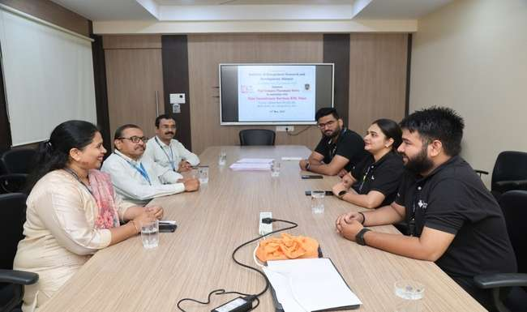

**Discussion at Conference room with HR panel**

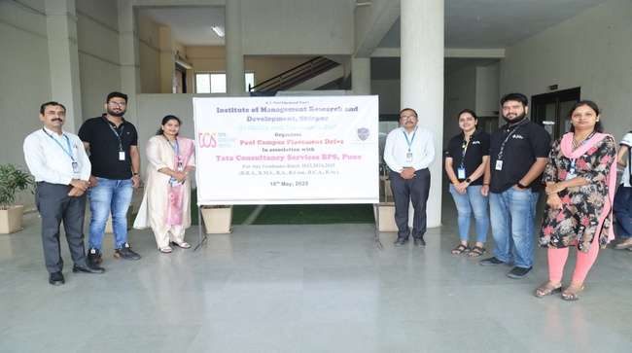

**Head of departments and T&P team with TCSBPS HR Team**

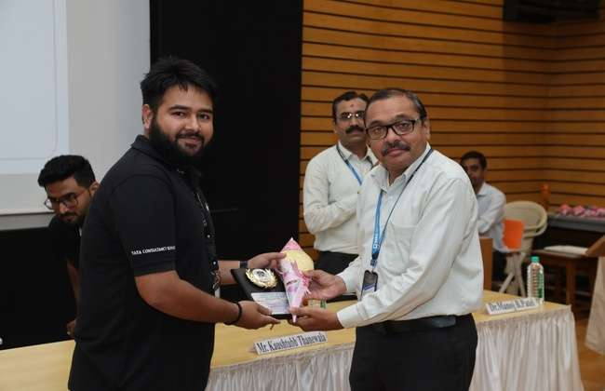

**Mr. Manoj Behere sir felicitating Mr. Rahul Giri Campus Lead & HR**

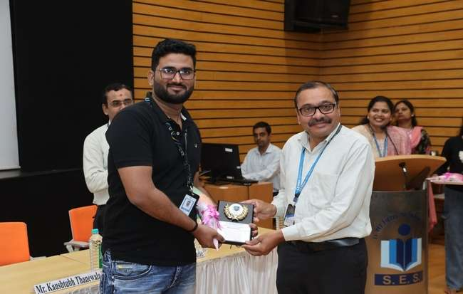

**Mr. Manoj Behere sir felicitating Mr. Kaushtubh Thanewala HR**

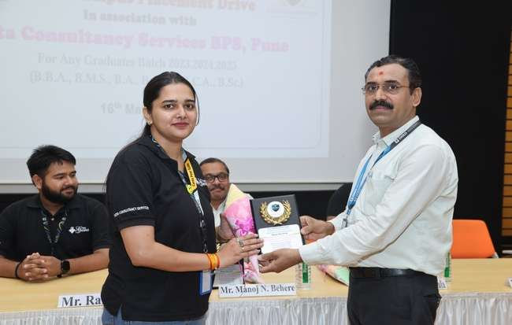

**Dr. Manoj Patel sir felicitating Ms. Arpita Mohanty HR**

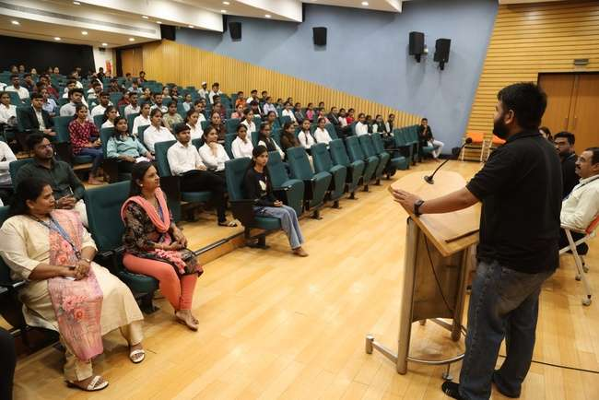

**Mr. Rahul Giri TCSBPS Campus lead and HR delivering preplacement talk**

**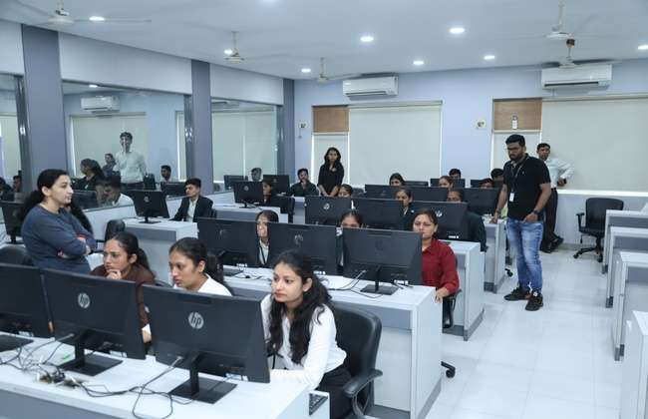  
Students participated in Aptitude Test**

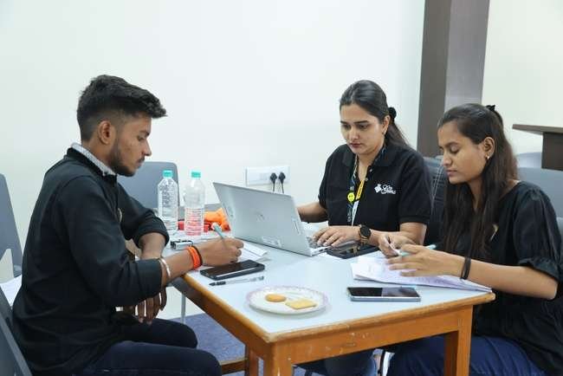

**Volunteers helping HR team**

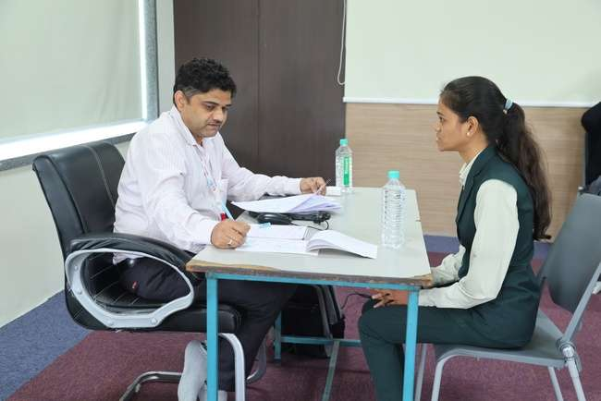

**Interview attended by students**

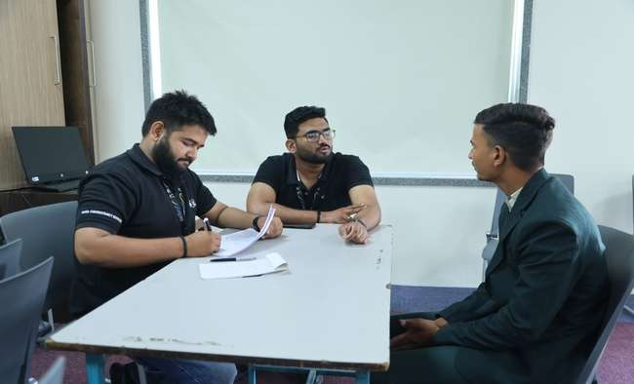

**Students with HR panel**

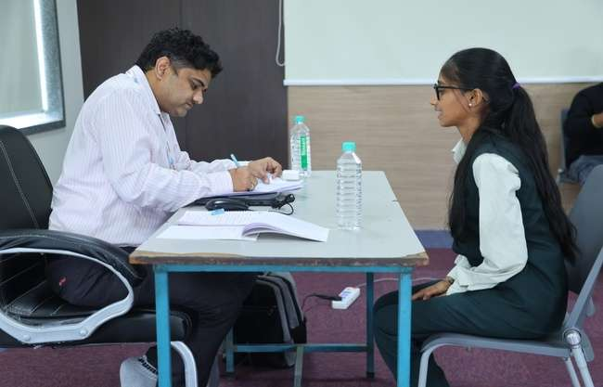

**Student’s selected in managerial round**

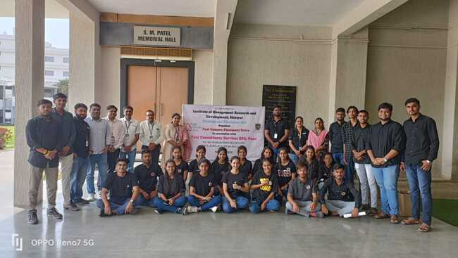

**TCS BPS team with faculty members and volunteer team**

**Activity Name: - गुणगौरव समारंभ 2024-2025**

**Date: -** 20-05-2025

**Venue: -** S. M. Patel Hall

**Number of Participants: -** 91

**Special Invitees**: Parents of Final Year Students.

**Class**: - BCA, BBA, BMS final year placed students.

**Objectives**: - The event was a prestigious initiative of the Training and Placement Cell aimed at celebrating the academic accomplishments and personal growth of the final year students of BCA, BBA, and BMS programs. The event served as a moment of pride for students, parents, and faculty alike, recognizing the hard work, perseverance, and transformation each student underwent throughout their academic journey. It was also a heartfelt opportunity to honour the support system behind every student their parents who were specially invited to witness and be a part of their children’s proud moment.

**Event Highlight**: The ceremony commenced with a warm and respectful welcome by Mr. Vijay Garge, extended to the Chief Guest Hon. Shri Rajgopalji Bhandari, Chairman of R. C. Patel Educational Trust,

and other esteemed dignitaries including Dr. Vaishali B. Patil, Director, IMRD, Mr. Manoj Behere, Assistant Director & Head of MCA and MCA Integrated, Dr. Manoj Patel, IQAC Coordinator,

Dr. Tushar Patel, Head, UG Department Parents, Faculty Members, and Students. The formal felicitation of the Chief Guest was carried out by Prof. Dr. V. B. Patil, who acknowledged his continuous support and visionary guidance in shaping the institute’s journey.

Mrs. Archana Jade, Training and Placement Officer, delivered an insightful opening address. She highlighted the placement milestones achieved by the students and appreciated the integral contributions made by faculty members and the unwavering support of the parents.

The program continued with heartfelt testimonials from selected students across all three streams. They shared their academic and personal journeys at IMRD, expressing deep gratitude toward faculty members and an emotional acknowledgment of their parents’ constant encouragement. Adding to the impact, a few parents also came forward to share their feedback, expressing appreciation for the institution and the initiative.

Prof. Dr. V. B. Patil addressed the audience, appreciating the dedication and growth of the students. She extended sincere thanks to the parents for placing their trust in the institution and assured them of IMRD’s ongoing commitment to excellence in education and career development. She also congratulated all the students who had successfully secured placements, recognizing their consistent efforts, commitment, and ability to translate learning into career opportunities.

Hon. Shri Rajgopalji Bhandari, in his motivational address, applauded the efforts of the Training and Placement Cell for organizing such a meaningful event. He emphasized how such programs strengthen the connection between students, institutions, and families. He extended his heartfelt congratulations to all the placed students, encouraging them to carry forward the values, discipline, and ethics instilled at IMRD as they embark on their professional journey.

Mrs. Sapana Yeshi, Assistant TPO, proposed the vote of thanks, expressing heartfelt gratitude to all dignitaries, faculty members, parents, and students for their active participation and support in making the event a grand success.

The ceremony concluded with a group photo session, capturing vibrant and joyful moments shared among students, faculty members, and parents. These photographs will serve as lifelong memories of this significant milestone.

The successful execution of Gungaurav Samarambh 2025 was a testament to the unwavering dedication, collaborative spirit, and meticulous planning of the, Head of departments, Training and Placement Committee Members and Parent-Teacher Coordinators. Mr. Manoj Behere, Dr. Manoj Patel, Dr. Tushar Patel Mrs. Archana Jade (TPO) and Mrs. Sapana Yeshi (Assistant TPO), the entire team worked tirelessly behind the scenes to ensure that every aspect of the event was flawlessly executed. From coordination and logistics to student engagement and guest management, the contributions of Dr. Amit Patil, Mr. Dinesh Borase, Mr. Vitthal Patil, Mr. Rahul Badgujar, Dr. Priyanka Bhandari, Dr. Asha Patil, Mrs. Rohini Patil, Mrs. Keertika Behere, Mrs. Dhanashree Patil, Ms. Harshada Chaudhari, Dr. Yogesh Sethiya, Mr. Kaustubh Sawant, Mr. Vijay Garge, Mr. Kedar Apte, and Mrs. Suvanna Chaudhari were instrumental. Their teamwork and commitment created an environment of celebration, pride, and seamless organization, making the event truly memorable for students, parents, and the entire IMRD family.

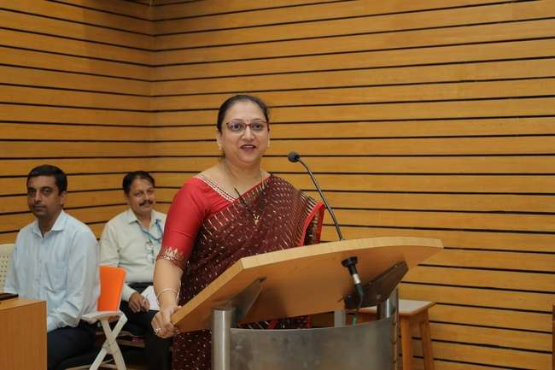

**Director Dr. Vaishali Patil Madam addressing students**

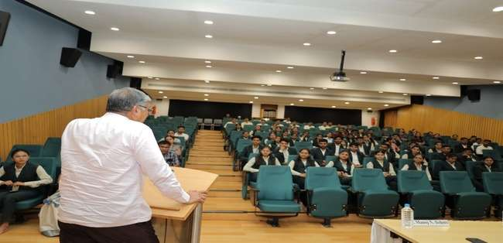

**Hon Rajgopalji Bhandari sir motivating students**

**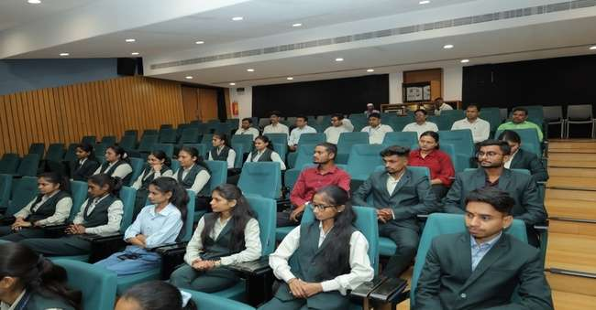  
Student’s participation in event**

**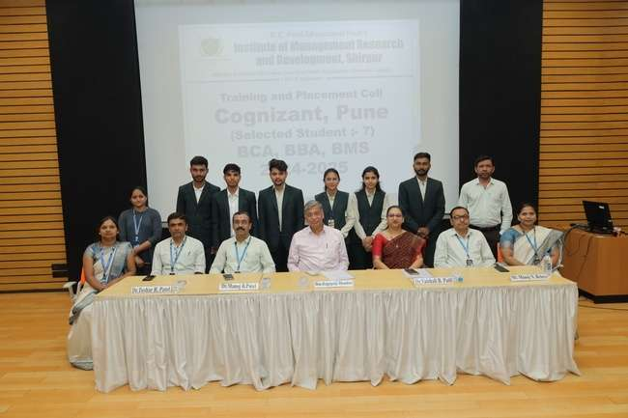  
Cognizant, Pune selected students with dignitaries**

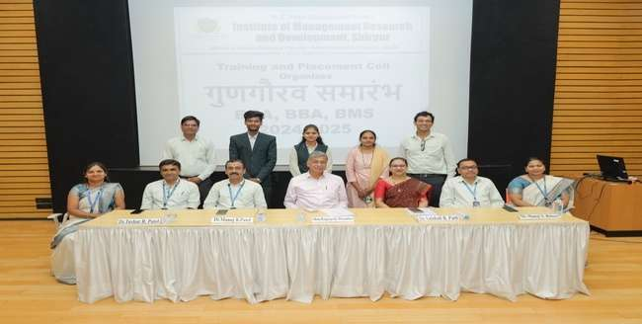

**Students placed in upgrade, Pune**

**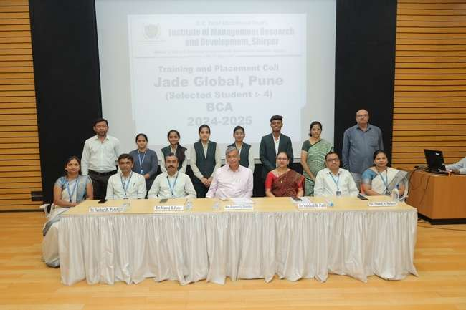  
Group of Jadeglobal, Pune with Dignitaries**

**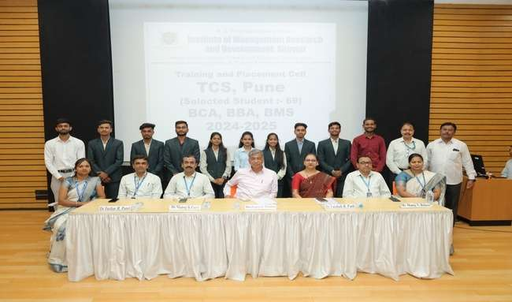  
TYBMS students placed in TCS, Pune**

**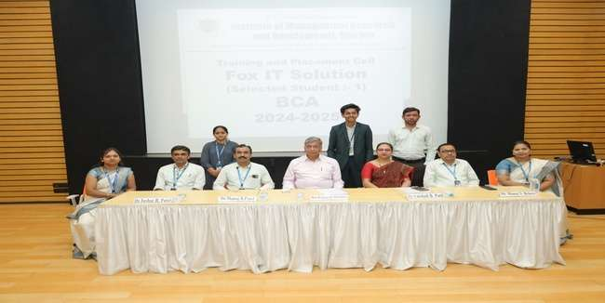  
Student placed in Fox Solution, Nashik**

**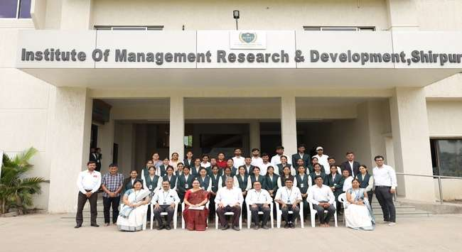  
Students of BBA placed in TCS, Pune**

**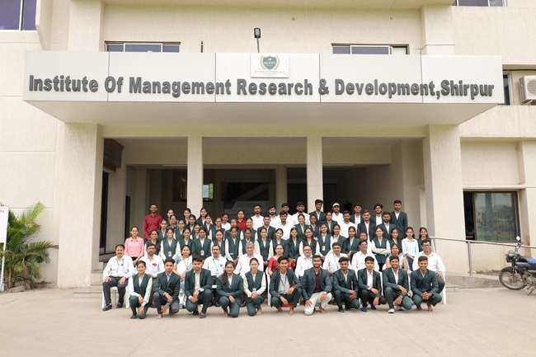  
BCA, BBA and BMS placed students with dignitaries.**