R. C. Patel Educational Trust’s

**Institute of Management Research and Development, Shirpur**

**Staff Welfare Committee 2024-2025**

**Index**

|  |  |  |  |  |  |
| --- | --- | --- | --- | --- | --- |
| **No.** | **Date** | **Name of activity** | **Particulars** | | **Total** |
| **Teaching** | **Non-Teaching** |
| 1 | 20/08/24 To 27/08/24 | One Week Staff Orientation Program | 49 | 0 | **49** |
| 2 | 19/10/24 | Hands on Session on Projector Configuration and Usage | 0 | 9 | **9** |
| 3 | 27/12/24 | How to Write Review Paper | 49 | 0 | **49** |
| 4 | 28/12/24 | Journal Indexing | 46 | 0 | **46** |
| 5 | 20/01/25 To 25/01/25 | One week Workshop on Aarogyam Dhan Sampada | 52 | 21 | **73** |
| 6 | 31/01/25 | Aanandi Jivanache Rahsya | 48 | 18 | **66** |
| 7 | 19/02/25 | Generative AI and Its Application | 55 (Sport Director, Librarian and Asst. Librarian including) | 0 | **55** |
| 8 | 20/02/2025 To 24/02/2025 | Five days Faculty Development Program on *“*Gnomio Moodle for infusing Outcome Based Education | 66 (52 IMRD + 14 RCPIT) | 0 | **66** |
| 9 | 22/03/25 | Workshop on Gas Safety, Firefighting and Safety Management | 45 | 19 | **64** |

**Event Name:** ***“One Week Staff Orientation Program”***

**Date:** 20/08/2024 to 27/08/2024

**Time:** 11:30 am to 01:30 pm **and** 03:30 pm to 05:30 pm

**Venue:** Activity Hall, IMRD

**No. of Participants:** 49 Faculty Members

**Resource Persons:**

1. Dr. Vaishali B. Patil (Director, IMRD, Shirpur)
2. Mr. Manoj N. Behere (Assistant Director, IMRD, Shirpur)
3. Dr. Manoj B. Patel (IQAC Coordinator, IMRD, Shirpur)
4. Dr. Tushar R. Patel (HOD UG, IMRD, Shirpur)
5. Mr. Sumit S. Sagale (Registrar, IMRD, Shirpur)
6. Dr. Yogesh C. Shethiya (Assistant Professor, IMRD, Shirpur)
7. Mrs. Kavita G. Patil (Librarian, IMRD, Shirpur)

**Event Highlights:**

Institute staff welfare committee organised one week ‘Staff Orientation Program’ for faculty members. This program is conducted in two slots for faculty members. The objective of this One week Staff Orientation Program was to deliver the information about Institute committees, working culture, NAAC policies, best practices, research motivation schemes, research resources at institute library, Course outcome and Program outcome attainment as per NEP-2020 which are essential for Institute and faculty progression.

Respected Director Dr. Vaishali B. Patil madam took session on ‘Institute overview and management initiative for faculty progression’. Mr. Sumit Sagale sir gave overview of ‘Timelab software, document compliance for research financial assistance’. IQAC coordinator Dr. Manoj B. Patel sir took session on different committee’s roles and responsibility towards NAAC documentation and records for academic performance indicators.

Respected Assistant Director Mr. Manoj Behere sir presented session on academic diary content and record. Respected HOD of UG Dr. Tushar Patel sir introduces examination structure, Course outcome and Program Outcome Attainment. Dr. Yogesh Shethiya sir introduces approaches to workplace excellence. Mrs. Kavita Patil madam introduced library assets and library systems available for staff and research tools.

Staff welfare committee coordinator Dr. Laxmikant Sharma, Committee members Mr.Sachin Surana, Mrs. Jyotsana Mali and Ms. Mrunal Bidkar carried responsibilities for successful execution of the program.

The detail day wise details as follows:-

|  |  |  |  |
| --- | --- | --- | --- |
| **Sr. No** | **Date** | **Name of Session** | **Resource Person** |
| 1 | 20/08/2024 | Institute Overview & Management Initiatives for Staff Progression | Dr.Vaishali B. Patil *Director* |
| 2 | 21/08/2024 | Timelab Software, Document compliance for research financial Assistance | Mr.Sumit S. Sagale *Registrar* |
| 3 | 22/08/2024 | NAAC Framework and Documentation | Dr. Manoj B. Patel *IQAC coordinator* |
| 4 | 23/08/2024 | Library Orientation and Research Tools | Mrs.Kavita G. Patil *Librarian* |
| 5 | 24/08/2024 | Examination Structure, Course Outcome and Program Outcome Attainment | Dr.Tushar R. Patel *HOD UG* |
| 6 | 26/08/2024 | Academic performance Indicators attainment and Faculty Diary | Mr.Manoj N. Behere *Assistant Director* |
| 7 | 27/08/2024 | Approaches to Workplace Excellence | Dr.Yogesh C.Shethiya *Assistant Professor* |

**7 days Orientation Programme details**

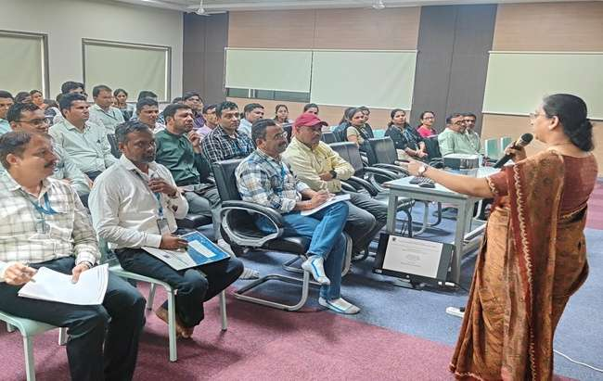

**Dr. Vaishali B. Patil Madam took session on ‘Institute overview and management initiative for faculty progression’**

**Event Name:** Session on “Hands on Session on Projector configuration and Usage”.

**Date:** 19th October 2024.

**Time:** 03:00 PM

**Venue:** Activity Hall, IMRD

**Resource Person:** Mr. Praful Patil

**No. of Participants:** 09

**Event Highlights:**

Institute’s Staff Welfare Committee organized a Session on “Hands on Session on Projector Configuration and Usage” On 19th October 2024. Mr. Praful Patil was resource person for this Session. The Objective of this Session was focused on the practical aspects of configuring and using projectors in various settings.

Mr. Praful Patil Provided an overview of the Projector and Configuration, features and specifications like brightness, resolution, throw distance. He explained usage of projectors to various devices, Adjusting settings for optimal display, Calibration for colour and image quality. Participants were benefited with the Hands on practiced connecting projectors to laptops and adjusting settings.

Staff welfare committee coordinator Dr. Laxmikant Sharma, Committee members Ms. Mrunal Bidkar and Mrs. Jyotsana Mali carried responsibilities for successful execution of the program.

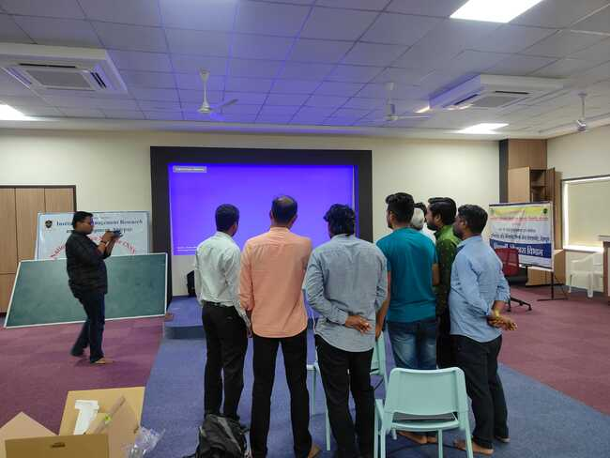

**Mr. Praful Patil during the Projector Session**

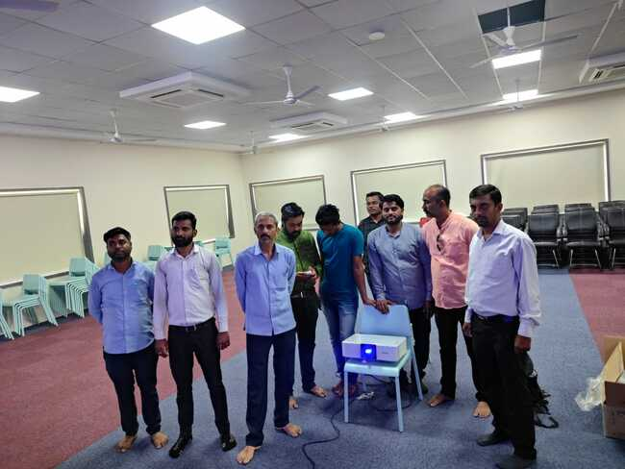

**Demonstration of the Projector Functions**

**Event Name: -** **Guidance Session on ‘How to Write a Review Paper’**

**Date: -** 27/12/2024

**Time: -** 03:00 pm to 04:00 pm

**Venue: -** Activity Hall, RCPET’s IMRD, Shirpur

**Resource Person: -** Dr. Asha R. Patil

**No. of Participants: -** 49

**Event Highlights:-** On 27th December 2024, Staff Welfare Committee of the institute had organized a guidance session on ‘How to Write a Review Paper’. This guidance session was planned with an intention to gain insight about Review paper and its content. Resource person for the session was Dr. Asha Patil mam from the institute. Director of the institute Dr. Vaishali Patil mam highlighted the importance of research and encouraged faculty members to participate in the upcoming seminars, and conferences. During preface Staff Welfare Committee Member Mr. Sachin Surana had given outline about review paper and its significance in the academic journey of every researcher.

The guidance session began with the overview on what exactly review paper means. Detailed structure and content of the review paper was highlighted using Power Point presentation. Every aspect of the review paper from selecting the topic of review paper to referencing and different citation styles were nicely explained. In addition to this, session highlighted significance of literature, how to explore literature relevant to the domain area. At the end of the session mam shown sample review paper for reference.

Session was concluded with questions answers session where various doubts of participants were cleared by resource person. IQAC Co-Ordinator Dr. Manoj B. Patel in the concluding remark explained how this session would be helpful for researcher to present and publish their research paper in the upcoming conferences organized by institute and other academic institutes. Jyotsna Mali mam proposed vote of thanks for the session.

Assistant director and HOD of MCA, IMCA department Mr. Manoj N. Behere, HOD of UG department Dr. Tushar R. Patel, IQAC co-ordinator Dr. Manoj B. Patel and 45 faculty members were presented for this guidance session.

Staff Welfare Committee coordinator Dr. Laxmikant Sharma, Committee members Mr.Sachin Surana, Mrs. Jyotsana Mali, Mrs. Kirtika N. Behere and Ms. Mrunal Bidkar, carried out assigned responsibilities for successful execution of the session.

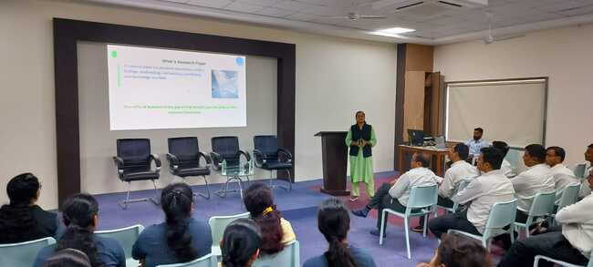

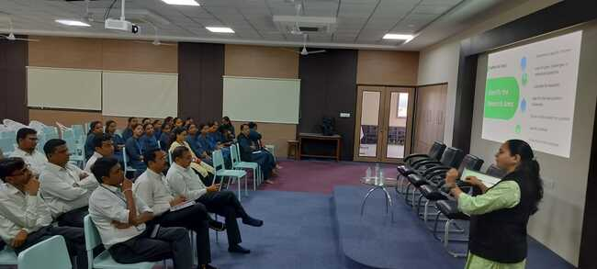

**Dr. Asha Patil Madam delivering the session**

**Event Name:** Guidance Session on “Journal Indexing”

**Date:** 28th December 2024

**Time:** 3.00 pm to 4.00 pm

**Venue:** Activity Hall, IMRD

**Resource Person:** Mrs. Kavita G. Patil (Librarian, RCPET, IMRD Shirpur)

**Number of Participants:** 46

**Event Highlights:-**

Institute’s Staff Welfare Committee organized a Session on *“*Journal Indexing*”* On 28th December 2024. Mrs. Kavita G. Patil an expert in academic publishing, conducted the session as part of an academic initiative aimed at enhancing participants understanding of academic publishing and the significance of journal indexing.

The main objective of the session was to provide participants with insights into popular indexing databases and their crucial role in academic research.

The session started with Mrs. Kavita G. Patil explaining what journal indexing is and why it is important in academic publishing. She discussed how indexing in trusted databases helps improve the visibility of journals and research articles.

Mrs. Kavita Patil also shared useful information about different indexing databases, their criteria for accepting journals, and how being indexed can increase the impact and citations of academic work.

The session was successfully organized by the Staff Welfare Committee. Dr. Laxmikant M. Sharma, the Committee Coordinator, along with committee members Mr. Sachin Surana, Mrs. Rohini Patil, Miss. Dipali Nhalde, Mrs. Kirtika Behere and Mrs. Jyotsna D. Mali took on various responsibilities to ensure the smooth execution of the session.

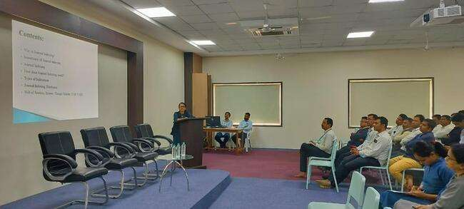

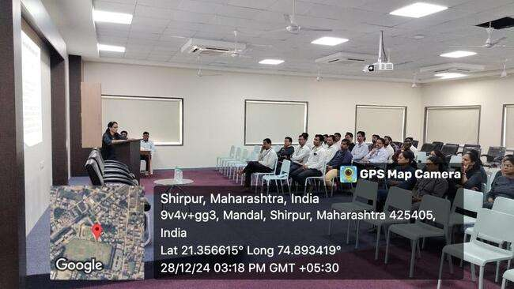

**Journal Indexing Session Conducted by Mrs. Kavita G. Patil**

**Event Name: -** ***One Week Workshop on “Aarogyam Dhan Sampada”***

**Date: -** 20/1/2025 to 25/1/2025

**Time: -** 3.00 to 5.00

**Venue: -** Activity Hall, IMRD Shirpur

**Resource Person:-**

Dr. Shrikant P. Wadile (Acting President and Founder Member of Yog Vidya Dham Shirpur)

**No. of Participants:** 52 Teaching staff and 21 Administrative Staff Members

**Event Highlights: -** Institute’s Staff Welfare Committee successfully organized One week workshop on ***"Aarogyam Dhan Sampada"*** for all faculty members and Administrative staff, with the goal of promoting holistic wellness through Yoga, Meditation and healthy lifestyle practices. Dr. Shrikant Wadile, an esteemed Yoga expert and Acting President of Yog Vidya Dham Shirpur, was invited as the resource person for this workshop.

The workshop began with a felicitation of the resource person by Institute Director Dr. Vaishali Patil. In her inaugural address, Madam highlighted the importance of Yoga, Pranayama and Meditation in fostering strength, awareness and harmony between the mind and body.

**On the first day,** the focus was on meditation and its techniques. Dr. Shrikant Wadile began by explaining the benefits of meditation, emphasizing its ability to connect the mind and body. He introduced participants to ***‘Ashtanga Yoga’*** and explained the significance of ***"Om"*** in meditation. The session concluded with meditation practice.

**On the second day,** Dr. Shrikant Wadile along with Mr. Dipak Borse as a co-instructor demonstrated several key Yogasans including Vajarasana, Kamalasana, Pawanmuktasana, Bhujangasana and Makarasana. Participants practiced these Yogasan and learned about their role in improving flexibility, maintaining good health and enhancing overall physical well-being.

**On the third day,** Participants began with warm-up exercises, followed by postures such as Shashankasana, Pawanmuktasana, Makarasana and Bhujangasana. The session focused on stress reduction, body relaxation and promotes physical and mental balance.

**On the fourth day,** the workshop moved into advanced Yogasanas and Mudras. Dr. Shrikant Wadile introduced postures like Naukasana, Viparita Karani and Ekapadasana. Along with these Yogasan, he taught various Mudras such as Singhmudra, Marjaramudra, and Chaitanyamudra. The mudras were emphasized for their ability to improve balance, promote mental clarity and enhance the body’s energy flow.

**On the fifth day,** the workshop continued with pranayama (breathing exercises). Dr. Shrikant Wadile led the participants through postures like Bhujangasana, Shalabhasana, Dhanurasana, Pushtasana, Virasana, and Brahmari Pranayama. These practices aimed to improve circulation, lung capacity and overall mental health.

The final day of the workshop began with a session on Surya Namaskar, followed by a yoga practice that incorporated pranayama and postures like Dhanurasana and Shalabhasana. Dr. Shrikant Wadile emphasized how these practices enhance circulation and promote mental clarity. He also shared valuable insights on diet and nutrition, explaining the best eating practices for maintaining a healthy and balanced lifestyle. Dr. Shrikant Wadile stressed the importance of mindful eating and choosing foods that support both physical and mental health. Tulsi Detox Kahwa, made by Organic India with organic ingredients, was provided daily to all faculty members and administrative staff to support digestion and detoxification. This refreshing beverage was offered to each participant for health benefits. Additionally, Director Dr. Vaishali Patil felicitated Mr. Dipak Borse IMRD staff member for his completion of Yoga Shastra and active support to the workshop.

The successful execution of this workshop was made possible through the efforts of Dr. Laxmikant M. Sharma, the Staff Welfare Committee Coordinator, along with Committee Members Mr. Sachin Surana, Mrs. Rohini Patil, Ms. Dipali Nhalde, Mrs. Kritika Behere, Mrs. Jyostana Mali and Ms. Mrunal Bidkar.

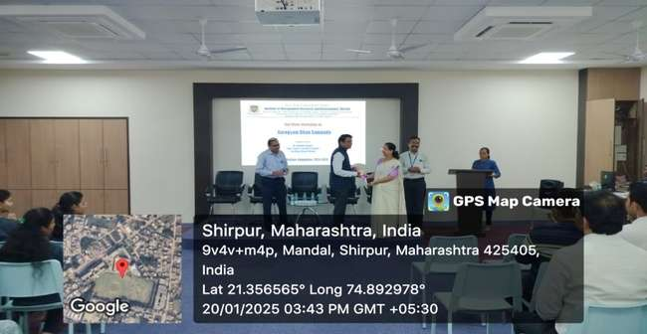

**Director Dr. Vaishali Patil while felicitating to resource person Dr. Shrikant Wadile**

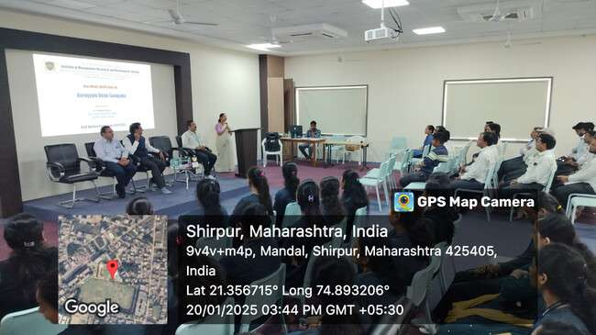 **Director Dr. Vaishali B. Patil while delivering an inaugural address**

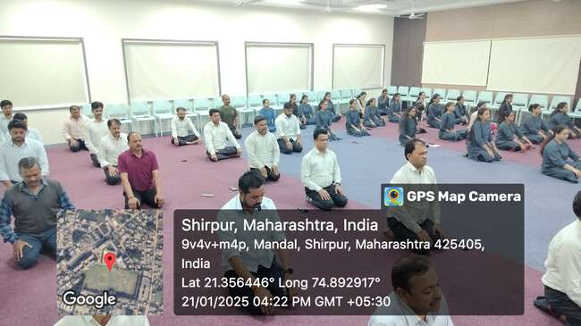

**Active Participation of all faculty members and Administrative staff**

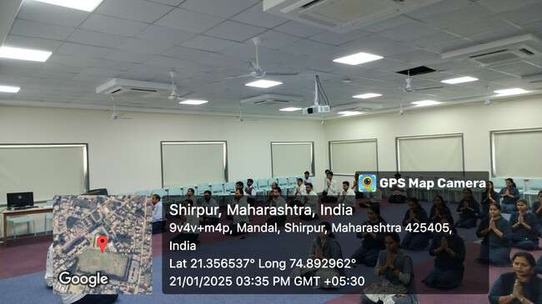

**All faculty members and Administrative staff during Workshop**

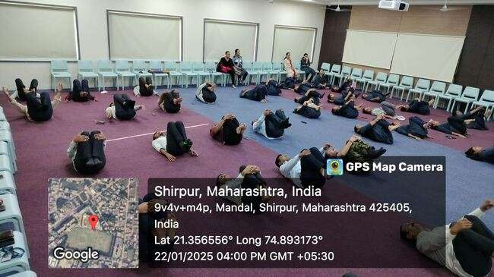

**All faculty members and Administrative staff during yoga practice**

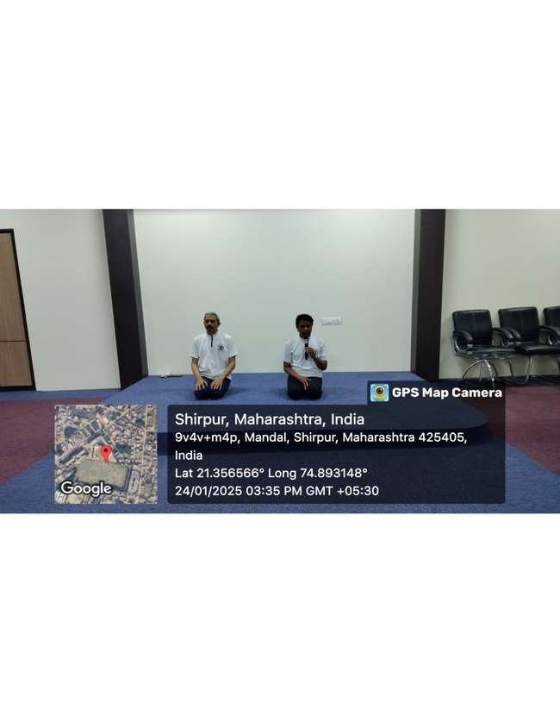

**Dr. Wadile along with Mr. Dipak Borse while demonstrated several key Yogasans**

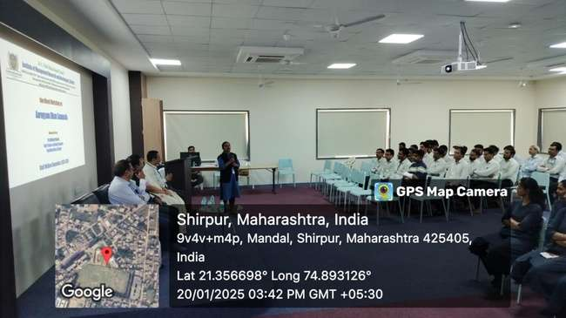

**Faculty member during Feedback session**

**Event Name : - *Motivational Session on “Aanandi Jivanache Rahsya”***

**Date: -** 31st January, 2025

**Time: -** 2.00 pm to 4.00 pm

**Venue : -** Activity Hall, IMRD Shirpur

**Resource Persons: -**

1. Dr. Limbaji Pratale (Director of Physical Education and Sports, SPDM College Shirpur)
2. Mr. Bharat R. Koli (Sport Teacher RCP College of Engineering and Polytechnic, Shirpur)

**No. of Participants:** 48 Teaching Staff and 18 Administrative Staff Members

**Event Highlights: -** Institute’s Staff Welfare Committee organized Motivational Session on ***“Aanandi Jivanache Rahsya”*** for all faculty members and Administrative staff, with the goal of the session aimed to promote mental well-being, encourage positive thinking and provides practical strategies for living a happy and stress-free life.

The session was conducted by Dr. Limbaji Pratale, the Director of Physical Education and Sports, SPDM College Shirpur and Mr. Bharat R. Koli, Sport Teacher R.C.P College of Engineering and Polytechnic, Shirpur

Dr. Limbaji Pratale primary goal was to help staff members manage work-life balance more effectively, reduce stress and cultivate a sense of happiness in both their personal and professional lives. During the session, resource person shared a wealth of knowledge on several key topics.

Mr. Bharat R. Koli emphasized the importance of managing stress by not taking unnecessary pressure and how essential it is to avoid stress in both personal and professional aspects of life. He also highlighted the power of finding joy in the small, often overlooked moments in life, encouraging all participants to focus on the little things that can bring happiness.

In addition to these insights, Dr. Limbaji Pratale offered practical health tips, such as the importance of ensuring 8 to 10 hours of quality sleep each night and maintaining a proper meal schedule, particularly ensuring that dinner is consumed on time.

He also introduced the concept of "switching in and out" mentally, which involves consciously managing the transition between personal and professional life, allowing individuals to maintain a healthy mental balance. Dr. Limbaji Pratale also shared simple yet effective practices for cultivating happiness, such as playing one’s favourite songs, dancing, to keep the session interactive and engaging, Dr. Limbaji Pratale incorporated various games that promoted teamwork and happiness.

The successful execution of this workshop was made possible through the efforts of Dr. Laxmikant M. Sharma, the Staff Welfare Committee Coordinator, along with Committee Members Mr. Sachin Surana, Mrs. Rohini Patil and Mrs. Jyostana Mali.

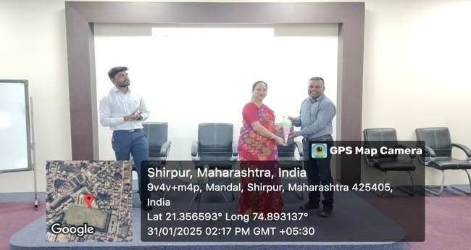

Director Dr. Vaishali Patil while felicitating to Resource Person Dr. Limbaji Pratale

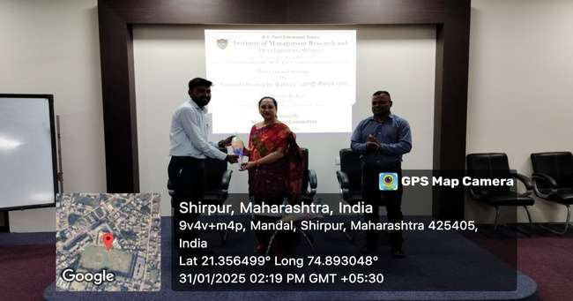

**Dr. Vaishali Patil Madam while felicitating to Resource Person Mr. Bharat R. Koli**

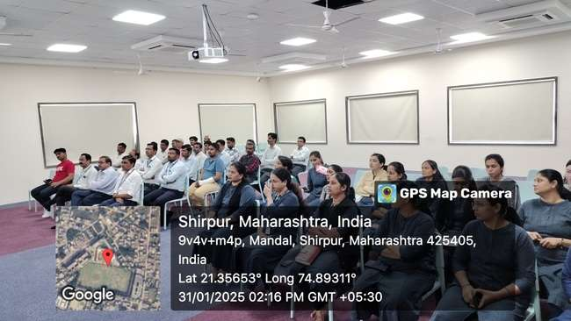**All faculty members and Administrative staff during Session**

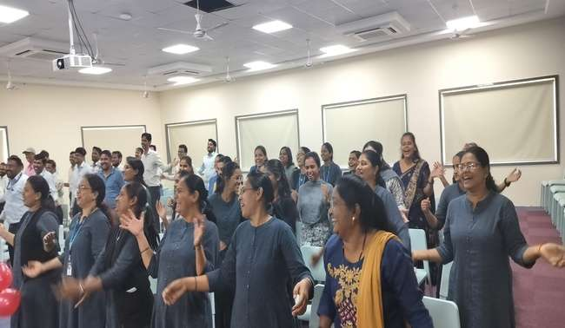

**All faculty members and Administrative staff during Happiness Practice**

**Event Name:** ***Expert Session on “Generative AI & Its Application”***

**Date:** 19th February 2025

**Time:** 11:30 AM to 12:30 PM

**Venue:** S.M. Patel Auditorium Hall, Shirpur

**No. of Participants:** 55 Staff Members

**Event Highlights:-**

An expert session on ***Generative AI & Its Application*** was held at Institute of Management Research and Development, Shirpur, organized by the Institute Research Committee. The session was for faculty members, with the goal of helping them understand Generative AI and its real-world applications. The session began with a traditional opening, offering a garland to Chatrapati Shivaji Maharaj and a Shiv Vandana, creating a respectful atmosphere.

Assistant Director Mr. Manoj Behere welcomed and Felicitated to Dr. Maya Ingale, the resource person for the session. Dr. Maya Ingale, Professor and Senior System Analyst at Devi Ahilya Vishwavidyalaya, Indore, began her talk by sharing motivational thoughts, inspired by Goddess Saraswati, Chatrapati Shivaji Maharaj and Rajmata Jijabai.

Resource person encouraged faculty members to value knowledge and dedication in their academic journeys. Dr. Maya Ingale also shared interesting historical insights about the lack of computer equipment and research centres in earlier times and how things have changed over the years.

During the session, resource person showed a documentary about the use of AI in various fields, giving a better understanding of its applications. She discussed several important topics related to AI, such as Lamda, AI domains, Big Data, Deep Learning, Neural Networks and Machine Learning.

She explained how these technologies work, how they are used in real-world scenarios, and shared examples like Alexa’s features. The session provided a thorough understanding of AI and how it’s used in many industries today.

The session was organized under the guidance of Institute Director Dr. Vaishali Patil Madam, contributed to the ongoing effort to promote research and learning at the institute.

Staff Welfare Committee Coordinator Dr. Laxmikant Sharma along with committee members Mr. Sachin Surana, Mrs. Rohini Patil and Mrs. Jyostana Mali all contributed to the smooth organization of the Session.

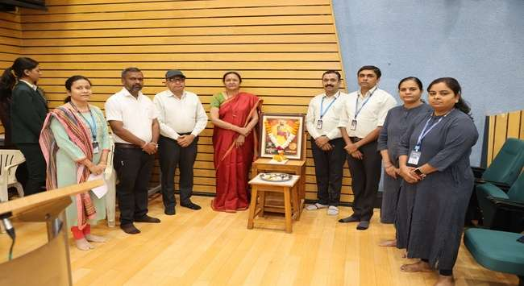

**Inaugration Ceremony of the expert session on *Generative AI & Its Application***

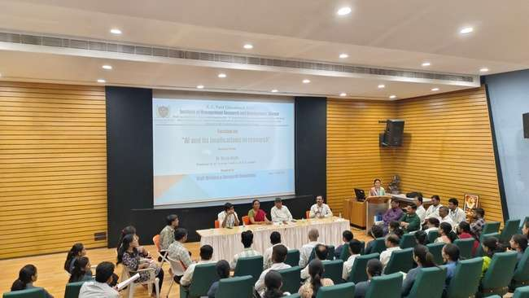

**Dr. Maya Ingale guiding to faculty members**

Event Name: FDP on Gnomio Moodle for infusing Outcome Based Education

**Date:** 20-2-2025 to 24-02-2025

**Time:** 9:00 am to 6:00 pm

**Venue:** Activity Hall and Computer Lab, IMRD

**Resource Persons:**

1. **Dr. Vinay Kulkarni**, Dean Quality Assurance OBE, D. Y. Patil Engineering College, Pune
2. **Ms. Mrunalini U. Buradkar**, Asst. Prof. St. Vincent Pallotti college of Engineering and Technology, Nagpur

**No. of Participants: 66 Faculty Members (IMRD & RCPIT)**

**Event Highlights:**

A Faculty Development Program (FDP) on Gnomio Moodle for infusing Outcome Based Education was conducted from 20th February 2025 to 24th February 2025, aimed at enhancing to explore the power of Moodle to enhance the quality of education and contribute to the overall development of our institute.

Moodle is one of the leading open-source learning management systems i.e. LMS, widely used for creating engaging and dynamic online learning environments for students by teachers. Its flexibility, adaptability, and open-source nature make it an invaluable tool for institutions aiming to improve the quality of education they provide.

In this five day’s FDP we explored and learned core Moodle’s features along with hands-on session. The primary focused of this FDP created one roof for learning material for students. The FDP was organized with two expert trainees as eminent resource persons: Dr. Vinay Kulkarni Sir and Mrs. Mrunalini Buradkar Madam both highly experienced professionals.

The FDP was scheduled from 9:00 am to 6:00 pm each day, incorporating a mix of theoretical knowledge, practical sessions, and assignments to ensure a comprehensive learning experience. In this FDP total 66 faculty members ware present.

**Objective of the FDP:** The primary objective of this Faculty Development Program was to provide faculty members with:

* + Enhanced teaching methodologies and modern pedagogical techniques.
  + Practical knowledge and strategies for curriculum design and delivery.
  + Insights into new educational technologies and tools.
  + Opportunities to engage in interactive sessions that will help improve their overall teaching and research capabilities.

**Brief Overview of FDP Sessions:**

**Session 1:** The session began with a brief introduction to Gnomio Moodle and its accreditation perspective, followed by instructions on creating an account and navigating the Moodle dashboard. Participants then learned how to create courses, categories, and sessions in Moodle. Afterward, they engaged in hands-on activities, creating accounts and navigating the Moodle dashboard, gaining valuable experience related to the subject matter. This smooth transition allowed participants to immediately apply the theoretical knowledge in a practical setting.

**Session 2:** This session began with instructions on logging in as a teacher and admin, followed by the process of creating a course, including categories, sections, and modules. Participants learned how to add resources such as PDFs, videos, quiz, puzzles and web links (using plugins). A hands-on session was conducted to help participants create announcements and set up discussion forums. The session also covered Moodle Roles & Permissions, comparing the roles of admin, teachers and students, and explained the feedback mechanism.

**Session 3:** In this session the participants developed their understanding by exploring the integration of copyrights, the creation of quizzes, and the importance of PO-CO and PSO mapping in the academic framework, creating glossary, Wikis, Chat, Monitoring Student Progress & Analytics and Peer Review. These sessions helped participants ensure that their courses meet both academic standards and legal guidelines using Quizzes & Question Banks in Moodle (CO-PO/PSO mapping and attainment).

**Session 4:** In this session focused on Research Paper Writing and the integration of external tools such as plugins and third-party tools in Moodle. Participants also learned about Moodle Analytics, which allows them to assess student performance, and discussed essential security practices to ensure the platform’s integrity Videos, SCORM, and Interactive Content (Inclusion of Vision, Mission, POs, COs, PEOs, PSOs etc.), creation of Games like Crossword, Snake and Ladder and Gamification like Badges, Rewards.

**Session 5:** The final session highlight was a panel discussion on the future of Learning Management Systems (LMS) in higher education, where experts shared insights into the evolving role of LMS platforms like Moodle also focused on Moodle's security and privacy features, implementation roadmaps for institutions, and efficient assessment and certification processes. The event concluded with final project submissions, a review session, and feedback from participants.

The valedictory session began with a certificate distribution ceremony, attended by esteemed dignitaries including Dr. Vinay Kulkarni, Ms. Mrunalini Buradkar, Director of IMRD Dr. Vaishali Patil, HOD of PG department, Mr. Manoj Behere, IQAC Coordinator Dr. Manoj Patel, and HOD of UG department Dr. Tushar Patel. The session concluded and vote of thanks delivered by Dr. D. M. Marathe marking the successful completion of the FDP.

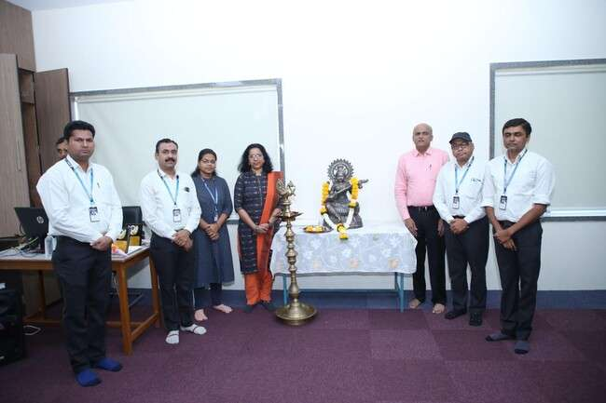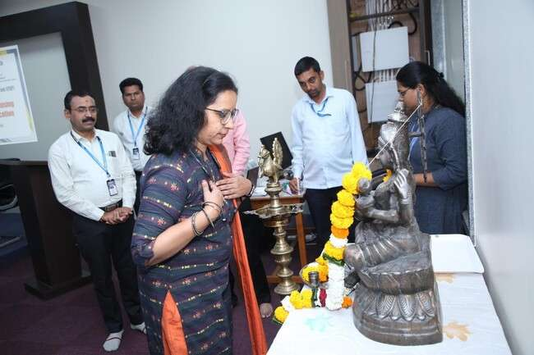

**Glimpses of FDP Inauguration with Expert and dignitaries by Sarwasti pujan and lighting**

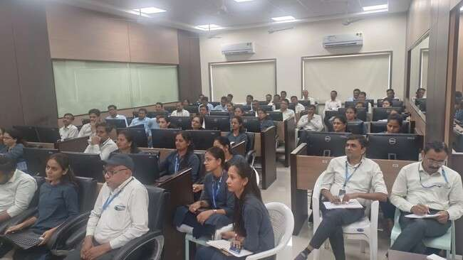

**Expert delivered Demonstration of Moodle feature**

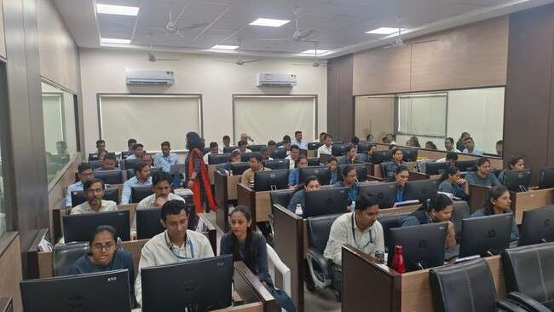

**Hands-on session for courses creation**

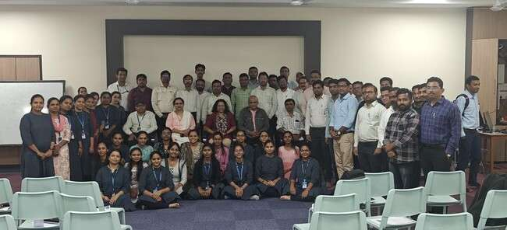

**Group photo of all participants with dignitaries and Experts**

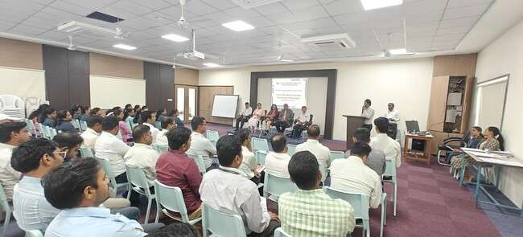

**Feedback delivered by Dr. Laxmikant Sharma**

**Respected Director Dr. Vaishali Patil delivered motivational four words to faculties of IMRD**

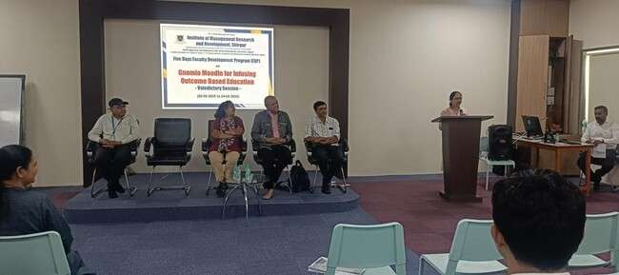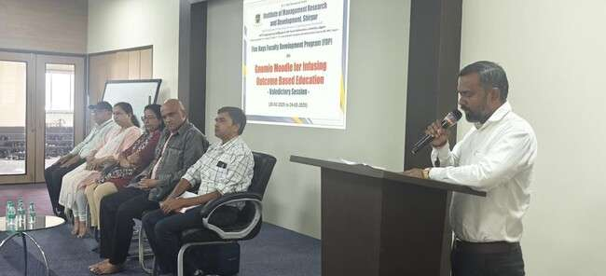

**Concluding and vote of thanks speech by Dr. D. M. Marathe**

**Event Name: -** “Workshop on Gas Safety, firefighting and Safety Management”

**Date: -** 22nd March 2025

**Resource Person: -** Mr. Amol Jadhav**,** Mr. Swaraj Unavane, Mr. R. R. Patil

**Number of Participants: -** 45 Teaching Staff & 19 Administrative Staff Members

**Venue: -** Activity Hall, IMRD

**Event Highlights:-**

The Institute’s Staff Welfare Committee organized a “workshop on Gas Safety, firefighting and safety management” on 22nd March 2025. Mr.Amol Jadhav, Mr.Swaraj Unavane, Mr.R.R. Patil was resource persons for this workshop.

The workshop aimed to provide employees with crucial knowledge and practical insights into handling gas safety issues, firefighting protocols, and effective safety management practices with live demonstration.

Mr. Amol Jadhav conducted a practical demonstration on how to safely check for gas leaks and manage situations involving potential gas hazards. He also explained how gas detectors work and provided tips on choosing and maintaining these devices.

The workshop was highly interactive, with staff members actively participating by asking questions and sharing their own experiences related to gas safety. Mr. Amol Jadhav addressed each query with in-depth explanations, ensuring that all Staff members understood the importance of safety measures.

The workshop was successfully organized by the Staff Welfare Committee. Dr. Laxmikant M. Sharma, the Committee Coordinator, along with committee members Mr. Sachin Surana, Mrs. Rohini Patil, Miss. Dipali Nhalde, Mrs. Kirtika Behere and Mrs. Jyotsna D. Mali took on various responsibilities to ensure the smooth execution of the session.

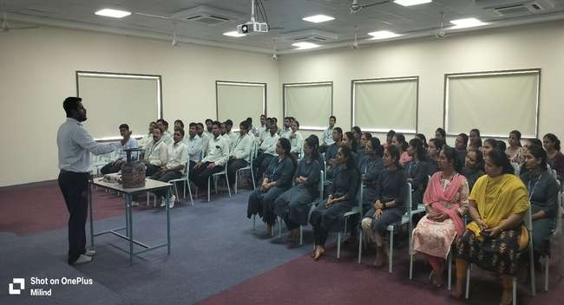

**Workshop on Gas Safety, firefighting and safety management**

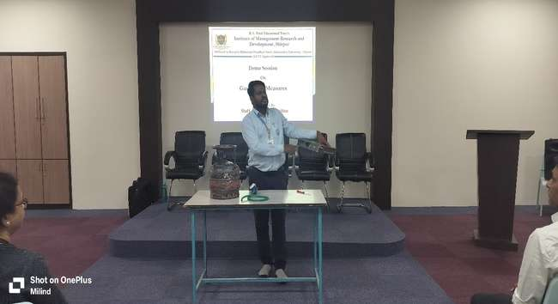

**Mr. Amol Jadhav demonstrating the fire safety measures**